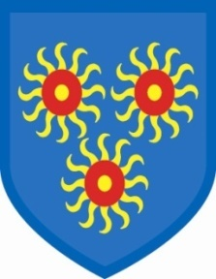
St Edmund’s Catholic Primary School

8th October, 2021
To Parents/Carers,
You will be aware that we have had several cases of Covid amongst children and staff. Covid is on the rise, with particularly high numbers in Tower Hamlets. In order to try and minimize the impact of this on the school, we have reintroduced several of the previous Covid measures. The bubbles are being maintained more strictly, the children are handwashing more and time for this has been built into class timetables. The cleaning regime has been reinforced so that classrooms and toilets are cleaned more often throughout the day.

All of the windows are being kept open and this is something that I need you to consider. As the weather gets colder, we will turn the heating on, but windows still have to be kept open to ensure that there is a flow of fresh air during school hours. Please consider putting extra clothes on your children, such as vests, t-shirts and, possibly, quilted gilets. Children do not feel the cold in the same way as adults, so we will be checking them to ensure that they are not too cold, but you can help by dressing them warmly during the winter months. As we have said before, children can wear wellington boots to school if it is raining, but they MUST bring shoes to change into. It is not good for their feet to wear boots all day.

I want to thank you all for your patience at the school gate – your support is so greatly appreciated by us.

Finally, many parents have been contacting me by phone or email if they have concerns. I am here for all parents and please feel free to contact me. I may not be able to get straight back to you, but I will always get back to you. You can leave messages with Shenaya and Jo Hannan at reception and I will contact you as soon as I can.

Thank you again for your support,

Gail O’Flaherty

