Black History Day – Whole School Curriculum & Assembly Plan
Date: Friday 24th October 2025
Theme: Black and British
Key Text: Black and British (children’s version) by David Olusoga
Culmination: Whole-School Assembly at 9:00 am (Hall)

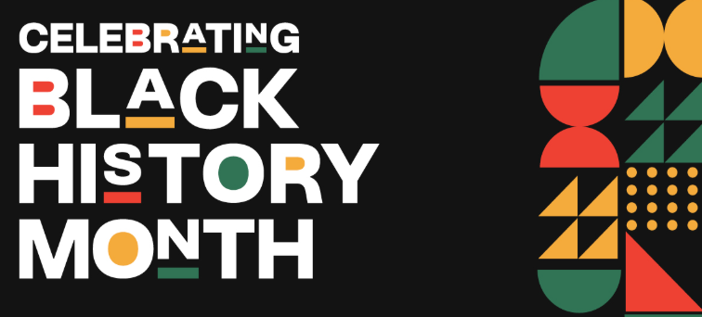

Phase / Year | Black History Focus & Activities | Ten Ten Curriculum Links | Assembly Contribution | Book Work / Evidence
EYFS | • Story time using picture books celebrating Black heritage (e.g. Look Up! or Handa’s Surprise)  • Circle-time about families, heritage and belonging  • Create handprint flags representing different heritages in the class | Module 1 – Created and Loved by God  👉 “I Am Me”  Module 3 – Created to Live in Community  👉 “Me, You, Us” | • Share flags and explain what they represent  • Display flags during assembly | • Stick flag craft into books with a dictated child sentence: “My family is from…” or “I belong…”  • Teacher scribes circle-time reflections
Year 1 | Focus: Modern Black Britons / Windrush Generation  • Read pages 172–205  • Look at stories of Windrush children arriving in Britain  • Worksheet comparing “then and now” (differences noticed by the Windrush Generation) | Module 1 – Created and Loved by God  👉 “I Am Unique”  Module 3 – Created to Live in Community  👉 “The Communities We Live In” | • Share worksheets and a few children explain their findings | • Stick worksheets into PSHE/History books  • Caption or sentence: “The Windrush children noticed…”
Year 2 | Focus: Empire, Trade & Migration  • Read pages 172–205 (Windrush)  • Create Migration Postcards imagining being a child arriving in Britain | Module 2 – Created to Love Others  👉 “Special People”  Module 3 – Created to Live in Community  👉 “Who is My Neighbour?” | • Read aloud a selection of postcards during assembly | • Stick postcards into PSHE/History books  • Add captions or speech bubbles imagining thoughts/feelings
Year 3 | Focus: Romans & Early Black Presence in Britain  • Read pages 9–21  • Learn about Africans in Roman Britain  • Design Roman Shields celebrating countries where Black soldiers came from; contrast with stereotypical Roman images | Module 1 – Created and Loved by God  👉 “We Don’t Have to Be the Same”  Module 3 – Created to Live in Community  👉 “A Community of Love” | • Show shields and briefly explain inspiration | • Stick shield designs or photos into books  • Reflection: “Romans came from many places including…”
Year 4 | Focus: Tudor & Stuart Period – John Blanke  • Explore John Blanke’s story and court life  • Create newspaper articles about his performances (or record news reports using iPads) | Module 3 – Created to Live in Community  👉 “How Do I Love Others?”  Module 1 – Religious Understanding  👉 “Get Up!” | • Read a few newspaper articles aloud or play video news reports | • Stick newspaper reports or screenshots into books  • Headline: “John Blanke at Court!”
Year 5 | Focus: 18th–19th Century – Slavery, Abolition, Early Migration  • Explore life during slavery & abolition  • Create Freedom Quilt Squares representing migration, hope, heritage, and freedom; combine into a large quilt | Module 2 – Created to Love Others  👉 “Under Pressure”  Module 3 – Created to Live in Community  👉 “Catholic Social Teaching” | • Present finished quilt and explain its symbolism | • Stick a photo of their square + short written reflection into books  • Class photo of full quilt
Year 6 | Focus: Second World War – Black Soldiers’ Contributions  • Research and create portraits of Black soldiers who fought for Britain  • Write short biographical captions celebrating their contributions | Module 1 – Created and Loved by God  👉 “Gifts and Talents”  Module 3 – Created to Live in Community  👉 “Reaching Out” | • Display portraits and read a few short biographies during assembly | • Stick portraits and biographies into books  • Optional: pupil reflection on why these stories matter today

Implementation Notes
- Book Titles: Write at the top of pages:
“Black History Day – Black and British (David Olusoga) – 23/10/25 – Linked to Ten Ten Life to the Full”
- Take clear photos of displays (freedom quilts, shields, news reports, portraits) and stick them in books with captions the following week.
- Encourage reflection writing after the assembly:
“Something new I learned about Black British history is…” or “I was inspired by…”
- This day supports SMSC, British Values (mutual respect & tolerance), and diversity education, as well as PSHE/RHE curriculum links.

