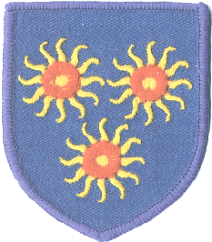

St Edmund’s RC Primary School

Diocese of Westminster

[www.st-edmunds-school.org/website](http://www.st-edmunds-school.org/website)

Follow us on twitter at: StEdmundsSchoo1

Newsletter to Parents

12th November, 2021

|  |  |
| --- | --- |
| .    **ST EDMUND‘S DAY**  [Image result for st edmund of abingdon](https://www.google.co.uk/url?sa=i&rct=j&q=&esrc=s&source=images&cd=&cad=rja&uact=8&ved=2ahUKEwiVjL2e7sHeAhVLzoUKHeG_CywQjRx6BAgBEAU&url=https://www.catholicforlife.com/saint-day-st-edmund-rich/&psig=AOvVaw2nb0d6gsxNl2_AdAEAOJyZ&ust=1541665628211774)  The feast day of St Edmund of Abingdon, the patron saint of our school, is on Tuesday, 16th November.  This day will be a non-uniform day and children can wear their own clothes. We will be having a party in the afternoon.  **SCHOOL DINNERS**  Lunch contour chipmunk clip art  Remember to tell our admin staff if your child is changing from a school dinner to a packed lunch, or a packed lunch to a school dinner. If your child is changing, this should only be done at the end of a half-term.    .  **DATES**  Monday, 15th November: Odd socks day (Anti-Bullying Week)  Tuesday, 16th November: St Edmund’s Day (Own clothes day)  Tuesday, 14th December: Children’s Christmas dinner in school.  Thursday, 16th December: Christmas parties in the afternoon. (Own clothes day)  Friday, 17th December: Last day of the term. **School finishes at 2pm. There is no after school care on this day.**  **DOODLE LEARNING**  DoodleLearning | Personalised Online Maths & English  Don’t forget to encourage your child to use Doodle Maths & Doodle English (your child can also access Doodle Tables and Doodle Spell). If you have lost login details, contact our admin staff who will inform your child’s teacher to contact you.  Classes with the greatest amount of children achieving their Doodle targets will win a weekly award!    **ANTI-BULLYING WEEK**  Sign up as a Supporter of Anti-Bullying Week: One Kind Word  Next week is Anti-Bullying Week which is coordinated in England and Wales by the Anti-Bullying Alliance and takes place from 15th to 19th November, 2021. This year’s theme is One Kind Word. The week will begin with Odd Socks Day on Monday, 15th November so please encourage your child to take part and wear odd socks to school on this day. More information can be found at: <https://anti-bullyingalliance.org.uk/anti-bullying-week/anti-bullying-week-2021-one-kind-word> | **LABELLING CLOTHES**  School Uniform - St Monica Primary School  Don’t forget that the school uniform items are identical for any given class. This makes finding the owner of lost items of clothing very difficult if they are not labelled with the child’s name. We implore you to label your child’s clothing, especially jumpers and coats, with their name.  **ADVENT APPEAL**  St Joseph&#39;s Hospice - Customer Case Study - Deputy  This year, our Advent appeal is for St Joseph’s Hospice in Hackney.  Watch this space to see how we will be raising funds. |

**ROAD SAFETY WEEK**

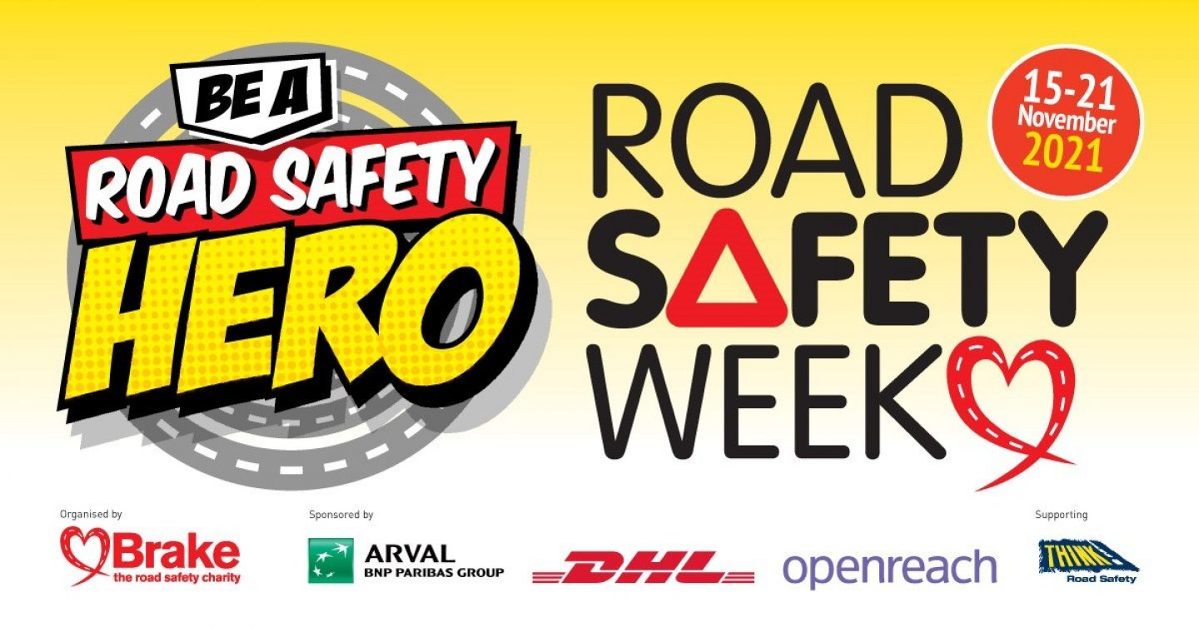

It is also Road Safety Week next week. The theme of Road Safety Week 2021 is ROAD SAFETY HEROES, celebrating the heroic work of road safety professionals and explaining how we can all play a part in making journeys safer for everyone. With this in mind, we remind you to avoid parking directly outside the school whenever possible and ensure engines are switched off when picking up or dropping off children.