St Edmund’s Catholic Primary School

Diocese of Westminster

[www.st-edmunds-school.org](http://www.st-edmunds.towerhamlets.sch.uk)

**Follow us on twitter @stedmundsschoo1**

Parents Newsletter 16th December 2019

**KS1 Nativity & KS2 Carol Concert.**

Many thanks to all who attended the Nativity Play and Carol Concert. All of the children and staff worked hard and both shows were fantastic!

**School Choir**

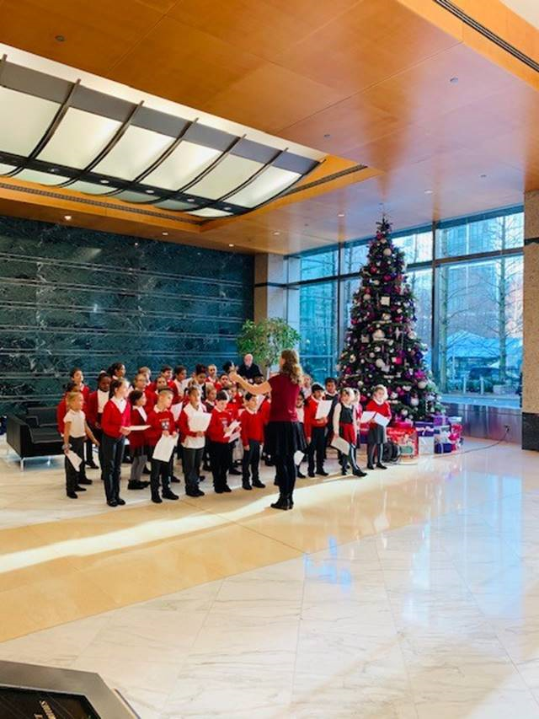

Well done to the St Edmund’s Choir who sang Christmas Carols at Westferry House and 50 Bank Street. They managed to raise £230 for the school and this will go towards paying for the coaches that take us on our annual trip to the seaside.

**Term dates**

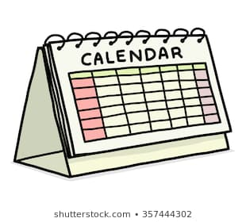

The last day of term is Friday. School closes at **2pm**. There will be **no after school care** on this day.

Monday 6th January: INSET day – school **closed.**

Tuesday 7th January: School re-opens for children.

Friday 31st January: INSET day – **school closed.**

**Key Stage 2 Results**

Good news & congratulations!

The revised KS2 data has been published and for Overall Performance, St Edmund’s are once again top of the table of Tower Hamlets schools.

Please see the compare school performance page on the DfE website.

**Christmas class parties**

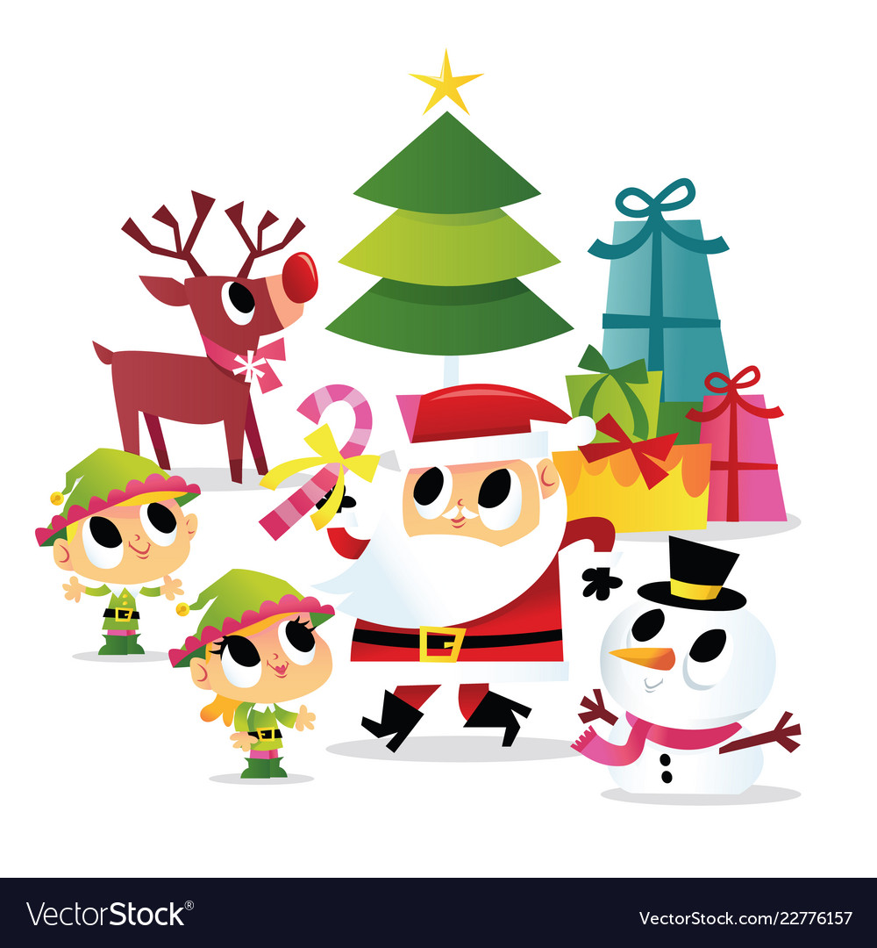

These will be taking place on

Thursday,19th December in class and children can wear their own clothes to school on this day.

**Advent Appeal**

[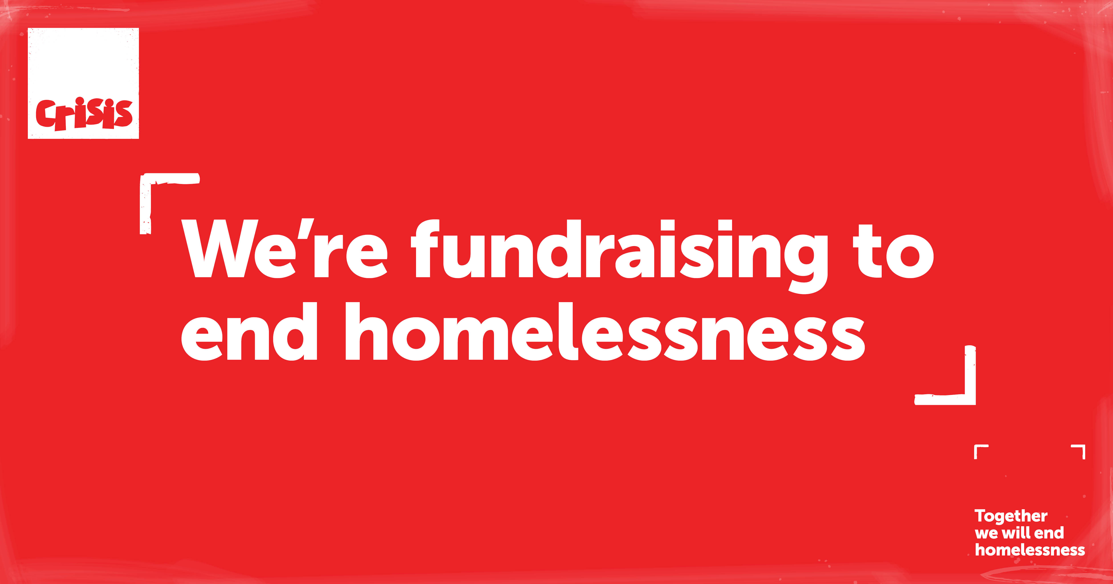](https://www.google.com/url?sa=i&rct=j&q=&esrc=s&source=images&cd=&cad=rja&uact=8&ved=&url=https://www.crisis.org.uk/get-involved/fundraise/get-fundraising-materials/digital-fundraising-materials/&psig=AOvVaw29AyzyzPrRuTQKD3KoFCWM&ust=1575476095216221)

Many thanks to all those who have taken part in the “scooterthon”. We are raising money to support the homeless through the charity “Crisis”. Each place at Crisis costs £28.78. We are hoping each class can raise enough money for 10 places. Please ensure that you hand your donations in to school before the end of term.



Foundation unit

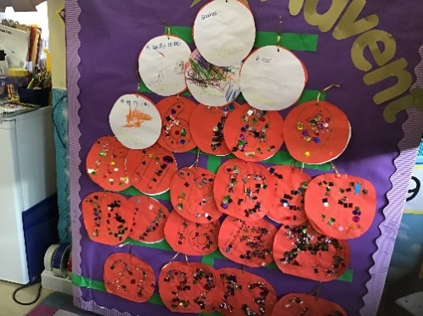

We have been getting ready for Christmas in lots of different ways. We made an Advent Calendar so that we can count down to Christmas day.

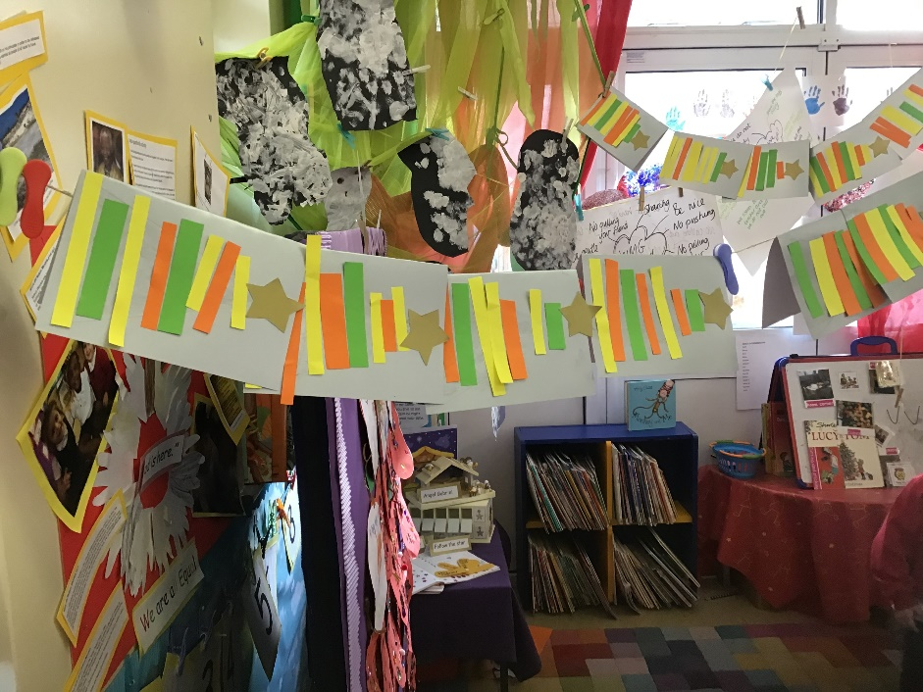

We have also been busy making Christmas cards,stockings and snowflakes. We are very excited!

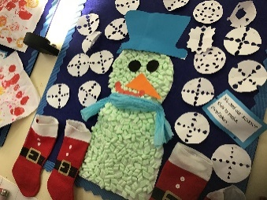

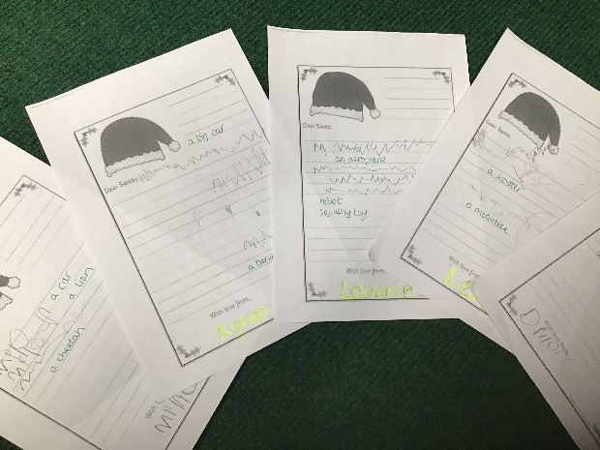

We have written our letters to Santa and the Postman came to pick them up so that he can deliver them to Santa’s Grotto, Reindeerland.

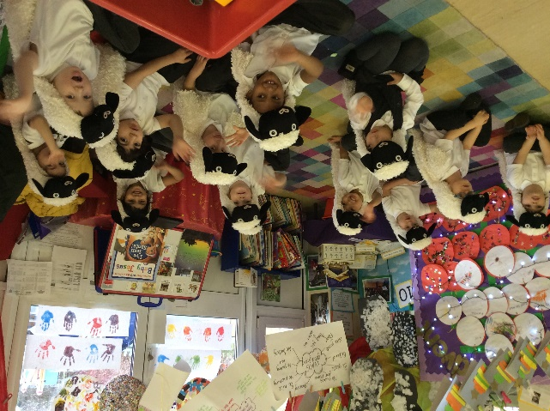

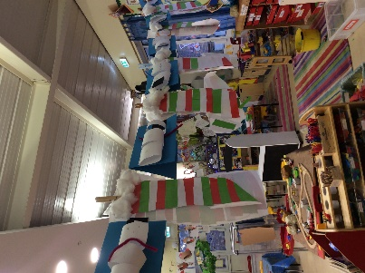

We would like to wish you all a very Merry Christmas and Happy New Year. We hope that you all have a restful and peaceful break and we look forward to welcoming the children back in January.

