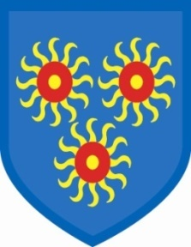
St Edmund’s Catholic Primary School

Tuesday, 8th March 2022
Support for Ukraine
I am sure you, like us, are horrified by the escalating conflict taking place in Ukraine. The fact that we can see it on our screens every day really brings home the sheer futility of war and the human cost of such actions.
We would like to join the people from all over the world in offering support to those suffering as a result of the conflict and join the Disasters Emergency Committee (DEC) in raising funds that will be used to support the people left in Ukraine and those who have managed to flee the fighting.
On Friday, 11th March (this Friday), the children can wear blue and yellow to school for a minimum donation of £1, but please donate as much as you can spare.
This money will go, as mentioned, to DEC, as the British Government has promised to match-fund the donations.
Please pray for the people of Ukraine, the people of Russia and all of our families who have connections with both countries. They need our prayers, our most heartfelt good wishes and our support.

Gail O’Flaherty

