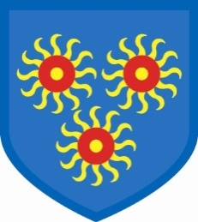 St Edmund’s Catholic Primary School

Diocese of Westminster

[www.st-edmunds-school.org](http://www.st-edmunds.towerhamlets.sch.uk)

**Follow us on twitter @stedmundsschoo1**

Parents Newsletter 23rd June 2021

**Parent Consultations**



These will be held remotely during the week beginning Monday, 5th July. Timetables for booking will soon be available online.



**Medication/Hayfever**



You cannot send any medicines into school with your child. We will also not give antibiotics. If your child requires maintenance medicines (for hay fever, asthma, etc.) please send, clearly labelled, to the school office.

**Summer School Uniform.**



Children can **only** wear plain black or plain white shoes or trainers. If children wear sandals they must have an ankle strap



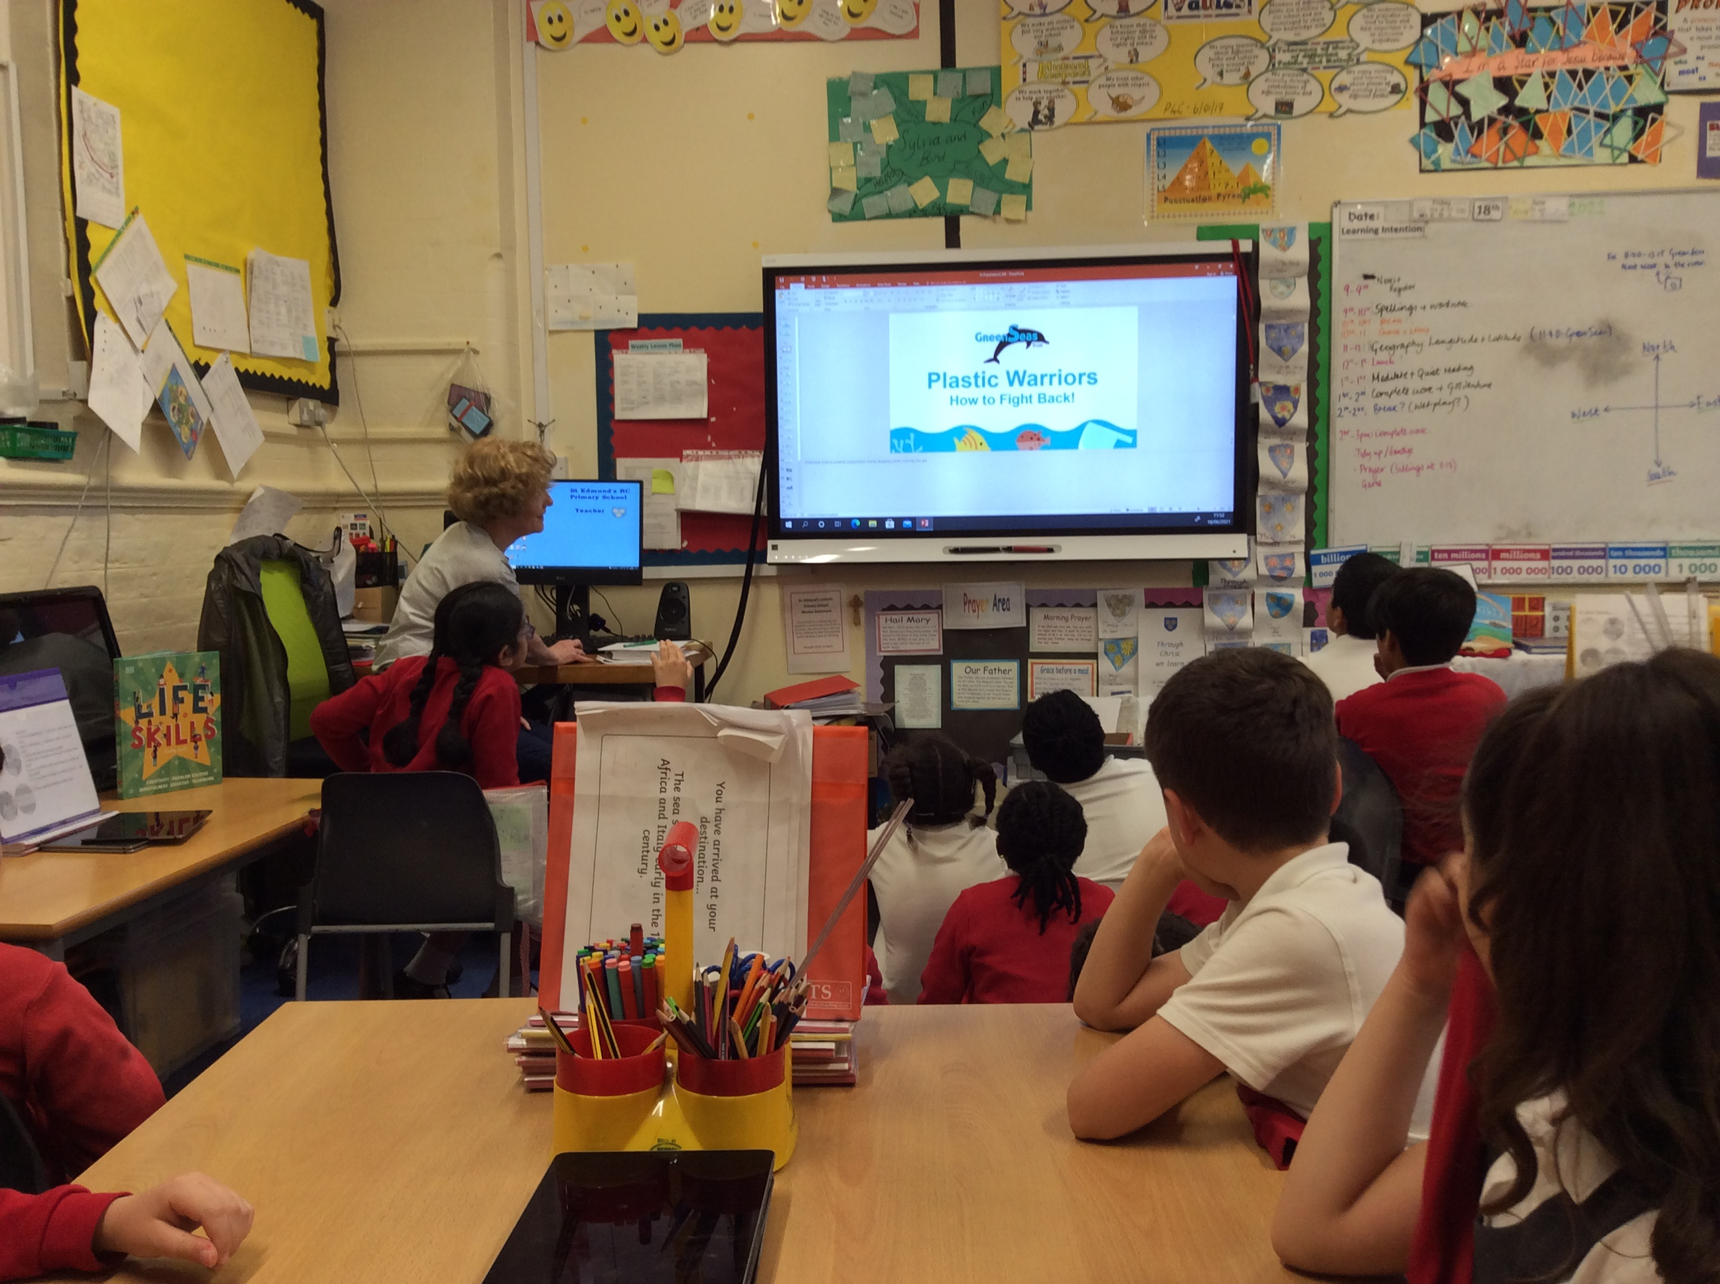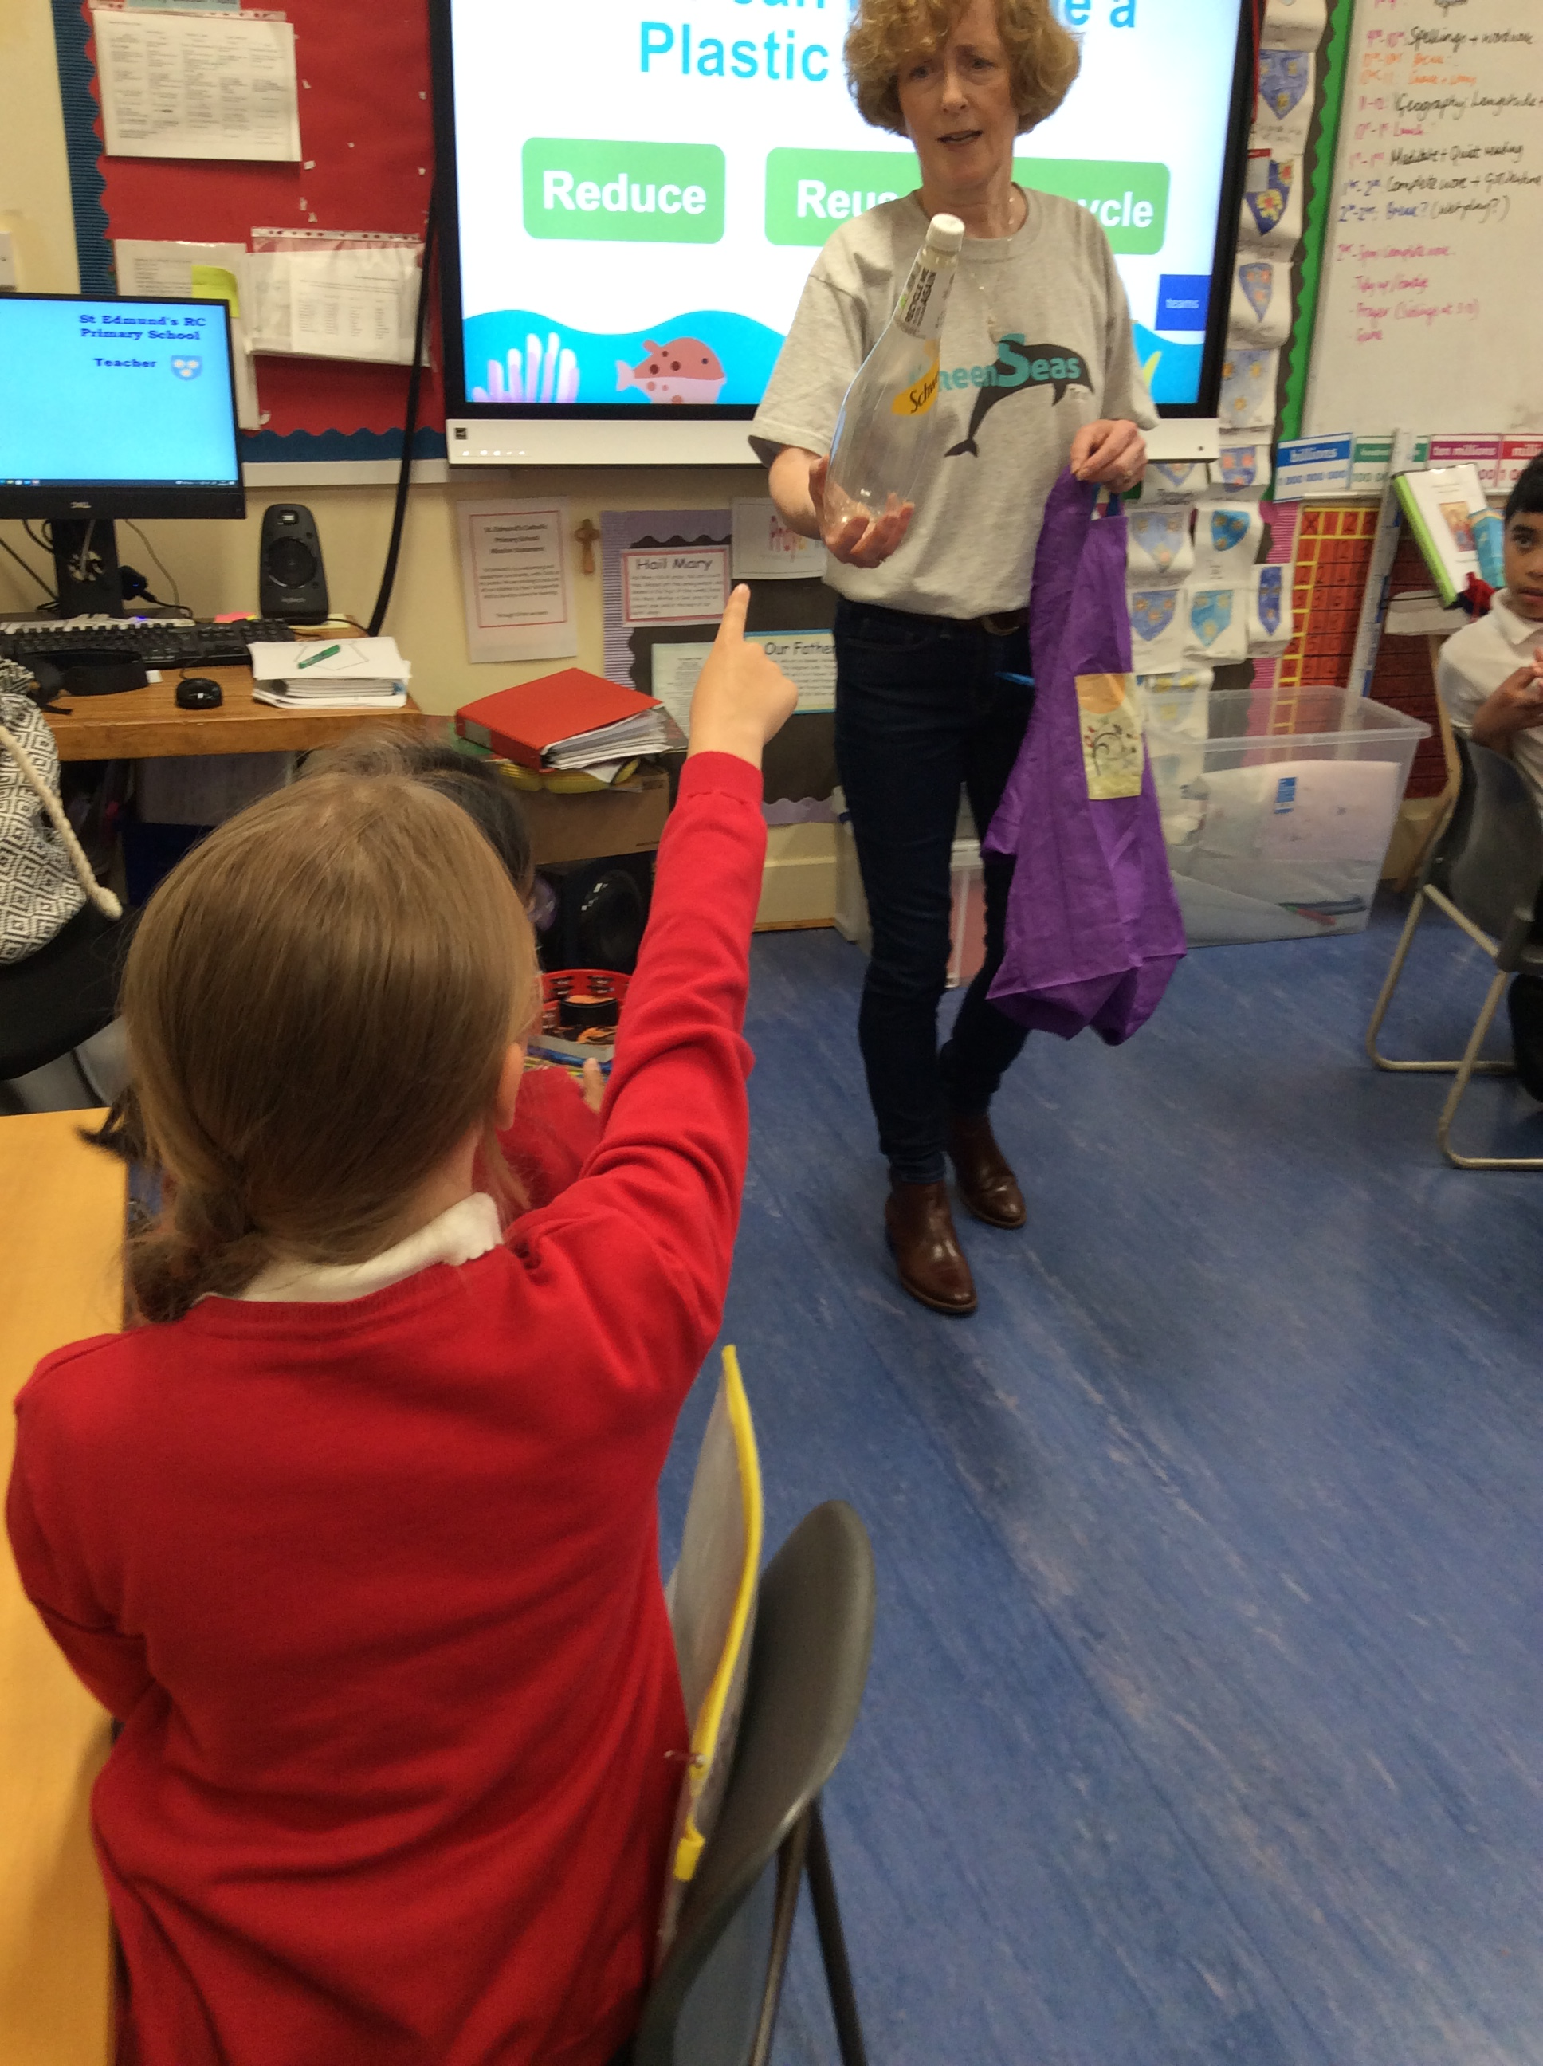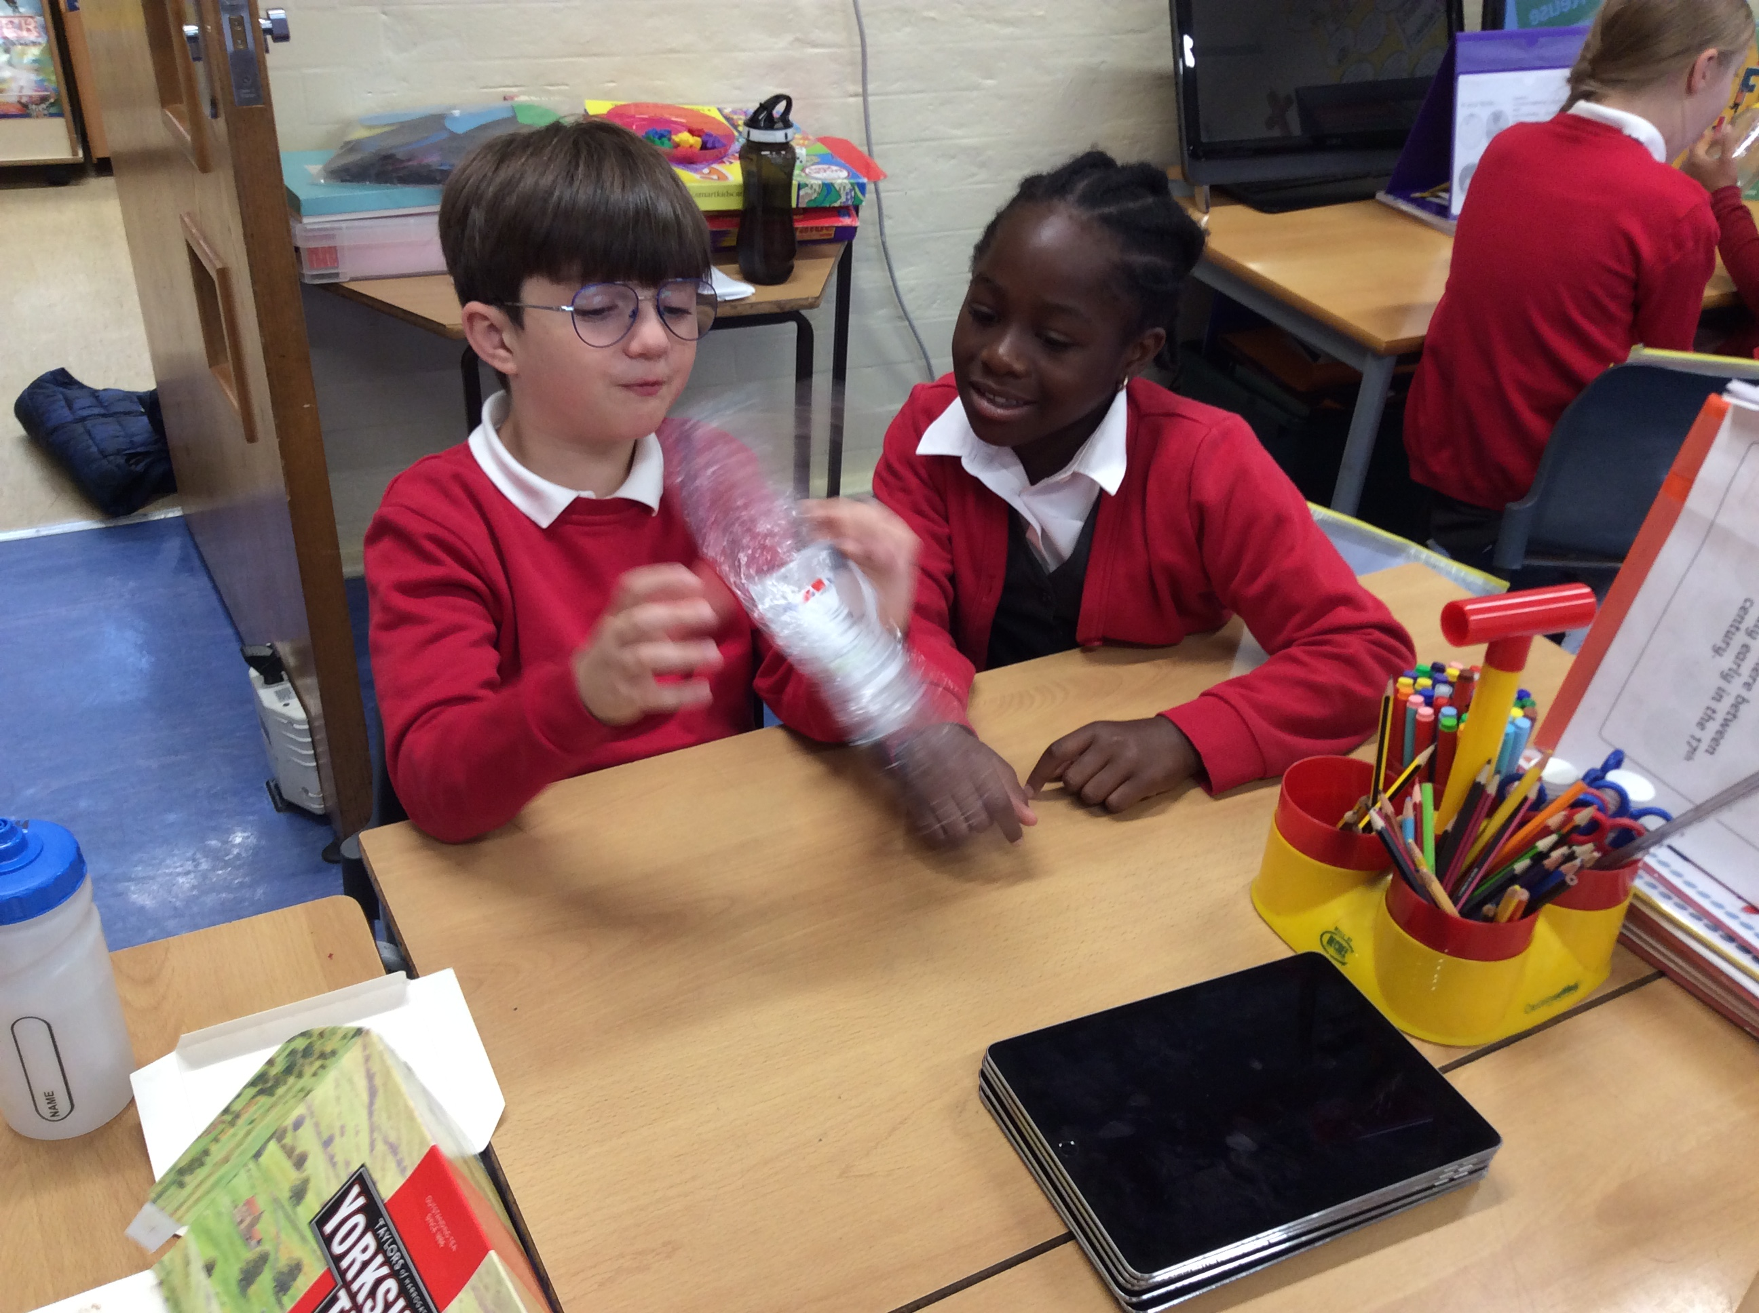

We are working with the charity, “GreenSeas”. They campaign to reduce the amount of plastic waste entering the oceans. The children are learning how to be Plastic Warriors and which packaging can be recycled or reused and which packaging materials we could use less.

Please support your child with the homework task from Greenseas, which is due on Friday, 25th June. The task is to repurpose some waste plastic into a practical or artistic object. The best work from each class will be rewarded with a prize, so children are encouraged to give this task their best efforts! Good luck, children.