St. Edmund’s Class Saints

Nursery  Peace | Reception  Peace | Year 1  Community | Year 2  Creation | Year 3  Dignity | Year 4  Philanthropy | Year 5  Virtuousness | Year 6  Solidarityy
St George  Patron saint of England, farmers and soldiers  Heavenly Father,  Give us the bravery of St George to stand up for what we believe.  Give us the strength to overcome the dragons in our lives and in the world.  And where we see people in distress, give us the courage to help them.  Amen. | St Nicholas  Patron saint of children  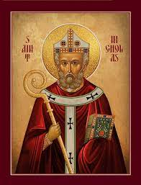  Loving God,  we thank you for the example of St. Nicholas,  who fed the hungry, brought hope to the imprisoned,  gave comfort to the lost, and taught the truth to all.  May we strive to imitate him by putting you first in all we do.  Give us the courage, love and strength of St. Nicholas, so that,  like him, we may serve you through loving our brothers and sisters.  Amen. | St Teresa of Calcutta Patron saint of missionaries of charity | St Paul  Patron saint of  Missionaries and evangelists | St Patrick  Patron saint of Ireland and engineers  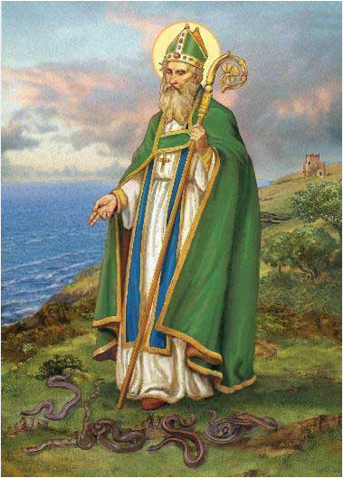 | St Ignacio de Loyola  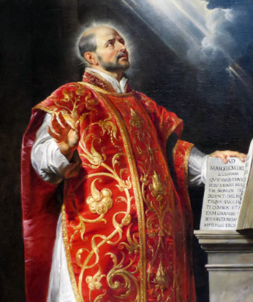  Patron saint of soldiers | St Thomas Becket  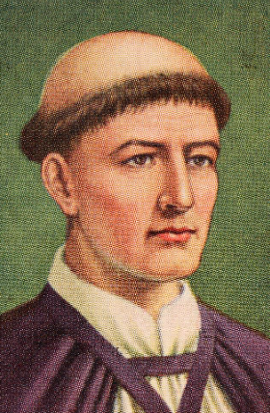  Patron saint of London | St Lawrence  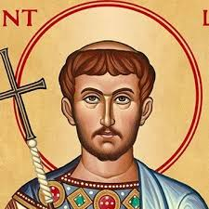  Patron saint of students
 |  | Saint Teresa of Calcutta,  Jesus called you to bring the light of His love to those who live in darkness. By tender, loving care for the poorest and the neediest, you became the sign of God’s presence, His love and compassion in the midst of suffering and pain.  Following your example, help us to recognise the face of Jesus in our suffering brothers and sisters and to serve Him with humility and joy. Teach us to be carriers of God’s tender love and mercy and so bear witness that God still loves the world through each one of us.  Amen. | O God, Who hast taught the multitude of the Gentiles by the preaching of blessed Paul the Apostle: grant unto us, we beseech Thee, that we who keep his memory sacred, may feel the might of his intercession before Thee.  Through Christ our Lord.  Amen. | God our Father,  you sent Saint Patrick to preach your glory to the people of Ireland.  By the help of his prayers,  may all Christians proclaim your love to all men.  Grant this through our Lord Jesus Christ, your Son,  who lives and reigns with you and the Holy Spirit,  one God, for ever and ever.  Amen. | Dearest Lord,  teach me to be generous;  teach me to serve You as You deserve;  to give and not to count the cost,  to fight and not to heed the wounds,  to toil and not to seek for rest,  to labour and not to ask for reward  save that of knowing I am doing Your Will.  Amen. | O God, for the sake of whose Church  the glorious Bishop Thomas fell,  grant, we beseech Thee,  that all who implore his aid,  may obtain the good fruit of their petition.  Through our Lord Jesus Christ,  who lives and reigns with Thee  in the unity of the Holy Spirit,  forever and ever. Amen. | O St. Lawrence, who in the flower of youth suffered and died for the faith, hear our prayers. With confidence we fly to your patronage. Obtain for us deep faith, strong hope, a sincere love of God and neighbour, unsullied chastity and humble obedience. Inspire us to succour the poor, the needy, the sick and the afflicted. Lead the erring back to the Father’s Home. May God’s Kingdom spread far and wide on earth. Help us in all our needs. Finally grant that we live as the worthy people of God, die a holy death and join you in the heavenly bliss forever. Amen.

