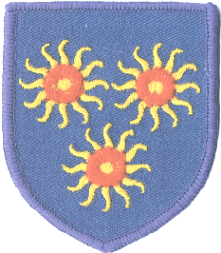

St Edmund’s Catholic Primary School
Newsletter
Diocese of Westminster
www.st-edmunds.towerhamlets.sch.uk
Follow us on @stedmundsschoo1

Newsletter to Parents: Wednesday 9th December,
2020

Advent Appeal-Christmas Jumper Day  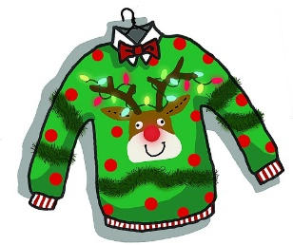  Don’t forget that on Friday, we will be raising funds for our Advent appeal; Crisis at Christmas and Dogs On The Street. Children should wear a festive jumper and bring in a contribution for the 2 charities. Children can wear their own trousers/skirts too. | Dates for your diaries  Friday 11th December: Christmas Jumper Day  Thursday 17th December: Christmas parties in the afternoon. Children can wear their own clothes.  Friday 18th December, School closes for the Christmas Holidays at normal closing time. (3.15pm-3.30pm)  Wednesday 6th January, School re-opens for children.
No Christmas Presents for Teachers & Staff  Due to COVID 19, we are not accepting presents this year. Please donate to our Advent appeal instead. Christmas cards are accepted and they should be posted in the school Christmas post box, where they will be quarantined for 3 days before being released. | Going Away Over Christmas?  We expect parents and children to self-isolate for 14 days if they are returning from a country, which is not in a UK designated travel corridor. Most European countries are not in the travel corridor! Because of this, we advise against such travel.  See the website below for more details.  Coronavirus (COVID-19): travel corridors - GOV.UK (www.gov.uk)  A Merry Christmas to You!  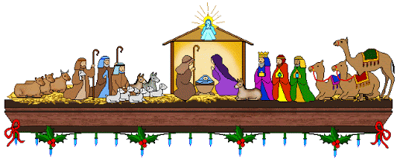  It has been a difficult year, but with your support, we have been able to continue quality education for your children. The Nativity story is one of managing in the face of adversity and we have all done just that.  The governors and all the staff at St Edmund’s would like to take this opportunity, to wish you a wonderful Christmas, to enjoy as best as you can.
Christmas Season Mass Times At The Church
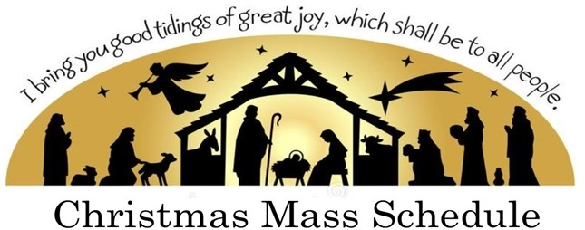

Christmas Eve, Thursday 24th December
Senior Citizens Mass: 4pm
Children’s Mass: 6pm
Midnight Mass: 12.00

Christmas Day, Friday 25th December
11 am

Boxing Day, Saturday 26^{h} December
6pm

Sunday 27th December - 9 am & 11 am
Monday 28th December - No Mass
Tuesday 29th December – 10.30am
Wednesday 30th December – No Mass
Thursday 31st December – 10.30 am
Friday 1st January – 10.30am
Saturday 2nd January – 6pm
Sunday 3rd January – 9am & 11 am

School Opening and Finish Times.

In case you have forgotten…..
Bubble | Start time | Finish time
Foundation Unit | 9.10 | 3.15
Years 1 & 2 | 9.05 | 3.20
Years 3 & 4 | 9.00 | 3.25
Years 5 & 6 | 8.55 | 3.30

Please observe these times, so we can avoid overcrowding at the school gate.

Start & Finish Times for Children With Siblings.
Remember, if you have more than 1 child at St Edmund’s, both siblings can start at the later time, (that of the younger child) and also finish at the earlier time, (again, the time of the younger child). This is to help you bring and collect your children and also to avoid parents waiting near the school gates for a long time.

