Catholic Social Teaching: Solidarity

Solidarity arises when we remember that we belong to each other. We reflect on this in a special way at Mass. The Catechism of the Catholic Church states, “The Eucharist commits us to the poor. To receive in truth, the Body and Blood of Christ given up for us, we must recognise Christ in the poorest.”

Summer Newsletter

Welcome back to school and to the summer term, the final term of the year. I hope you all had a wonderful Easter break and enjoyed eating lots of chocolate eggs.

Hopefully soon we will start enjoying warmer days and will see all children in their summer uniforms. We advise to apply sunscreen prior to the school day.

Medicine – some children may suffer from hay fever or other allergies; please speak to our Office staff if your child requires administration.

We are again looking to extend learning opportunities by continuing with class, whole school events and an extensive extra-curricular timetable! Full details will be shared in the usual ways using our newsletters and soon enough via Class Dojos, so please keep an eye out for special and important dates.

We will mark the King’s coronation by having a class tea parties on Friday 12th May at 2:30pm to 3:10pm followed by dismissal. Parents are asked to donate some celebration food so children can hare with the friends in their classrooms on the day.

Also, on 23rd May, we will carry out our annual Crowning of Our Lady as part of our Collective Worship. Parents are invited but seats are limited so please speak to office to reserve a seat. This is a ritual celebrated in the month of May where an image or statue of Mary is crowned with a wreath of flowers and honoured as the Queen of Heaven and the Mother of God.

Birthday celebrations – we always like to celebrate with our children their birthdays. As Healthy school, can we please try and avoid sweet snacks but instead offer fruit or even better – donate a book that children can enjoy.

All staff have continued to be incredibly impressed in the way that the children have continued with such positive attitudes to their learning, constantly displaying such wonderful levels of excitement and enthusiasm.
God Bless.

Mr Antonis Antoniou
Head of School

Message from the Executive Headteacher

Welcome back to you all.

In the words of Pope Francis, 'Happy Easter! May you bring to all the joy and hope of the Risen Christ’. Let us remember Jesus was the Prince of Peace; The Servant King; the humble one who taught others how to live in the way we should. Jesus did not ask us to take up the cross as he did but instead to make small sacrifices to help others; to show one another love; to help those in need; to be selfless and give what we can to help our brothers and sisters. Mother Theresa said, ‘We cannot all do great things, but we can all do small things with great love.’ Let us remember this in our daily lives and never underestimate the difference a small gesture can make.

This term is set to be another busy one! Please do take the time to read the newsletters & check our school platforms such as Class Dojo and our school websites regularly.

Spring is always such a wonderful time of the year. It is lovely to have the lighter nights returning and the feeling that Summer is well and truly on its way. Please do enjoy this time with your loved ones and I look forward to seeing you all soon.

Best wishes,
Mrs Ruthven

May – The Month of Mary

Many traditions in the Church have their roots in ancient times and the month of May is no different. For May we can look back at the ancient Greeks who dedicated the month of May to Artemis, their goddess of fecundity. The month of May was also significant to the Romans who honoured Flora, their goddess of bloom or blossoms. The Romans would celebrate “floral games” at the end of April ask for Flora’s intervention to help all things that bloom. For Catholics and many other Christians, May is an opportunity to speak to Mary and get to know her better. We can read the Gospels discover her as the Mother of Jesus and how as a young girl, she too would have felt fear of the unknown, just as many of us are feeling right now. We can also look to her faith and trust in God, knowing that He walks beside us and will catch us as we fall, always helping us to get back up again. Mary’s complete trust and obedience in God’s plan for her is inspirational, for if a young girl about to be married can so completely and absolutely put her life in God’s hands, then her example can bring us hope and comfort in these challenging days.

Why is May dedicated to Mary?

The devotion to Mary during the month of May started sometime in the Thirteenth Century and began as a way to encourage more non-religious practices to be replaced with more religious traditions and acts of worship and prayer. During this month, Catholics will offer up prayers and adoration to Mary both in Church and at home. In these difficult times we all need the loving care of Our Mother and it is important to remember that we can pray to Mary anywhere - through formulaic prayer or spontaneous prayer and meditation.

What can we do during May?

Pray the Rosary: In Fatima, Portugal in 1917, Mary appeared to three children and asked them to pray the Rosary to help save the world. Pope Saint John Paul II too insisted that everyone pray the Rosary for the peace and salvation of the family. Please feel free to upload your videos of you praying the Rosary with your family.

Introduction of New Roles:

We are delighted to introduce the two new important roles that existing members of our staff have successfully secured.

Mrs Paulla Dean as the Interim Assistant Head Teacher
Hello families,
Taking on the role of Interim Assistant Head Teacher at St. Edmund’s is a huge privilege for me! You may already know me as being the Year 5 class teacher for the past three years although I have been teaching in various schools and boroughs for nineteen years across all key stages. Over the coming years, I look forward to continuing the great work we have begun and working with you to secure a happy and successful future for all our wonderful pupils.

Mrs Maria Charles as the new Interim EYFS Leader
I am incredibly excited to be given this fantastic opportunity as interim EYFS leader. I have worked in the early years for 23 years and have a wealth of knowledge and experience. I look forward to leading the team and continuing the high standard of excellence in the foundation unit; I also look forward to working with the parents and families to develop their child’s education further and ensure each child has the most positive experience.

Introduction of new staff member:

We welcome Mrs Simran Goyal to St Edmund’s teaching team. She will be working alongside Mrs Dean in Y5.

Hi,
My name is Mrs Goyal and I am currently teaching in Year 5 till the end of the summer term. I am really enjoying my time at St Edmunds, in particular working with the lovely staff and children. I am looking forward to teaching more of the curriculum and learning the ways that the school works.

School Uniform
As the days are becoming warmer, our children should come to school dressed in their Summer Uniform. Please ensure that you refer to the School Uniform Policy and if you require assistance, please feel free to speak to the School Office.

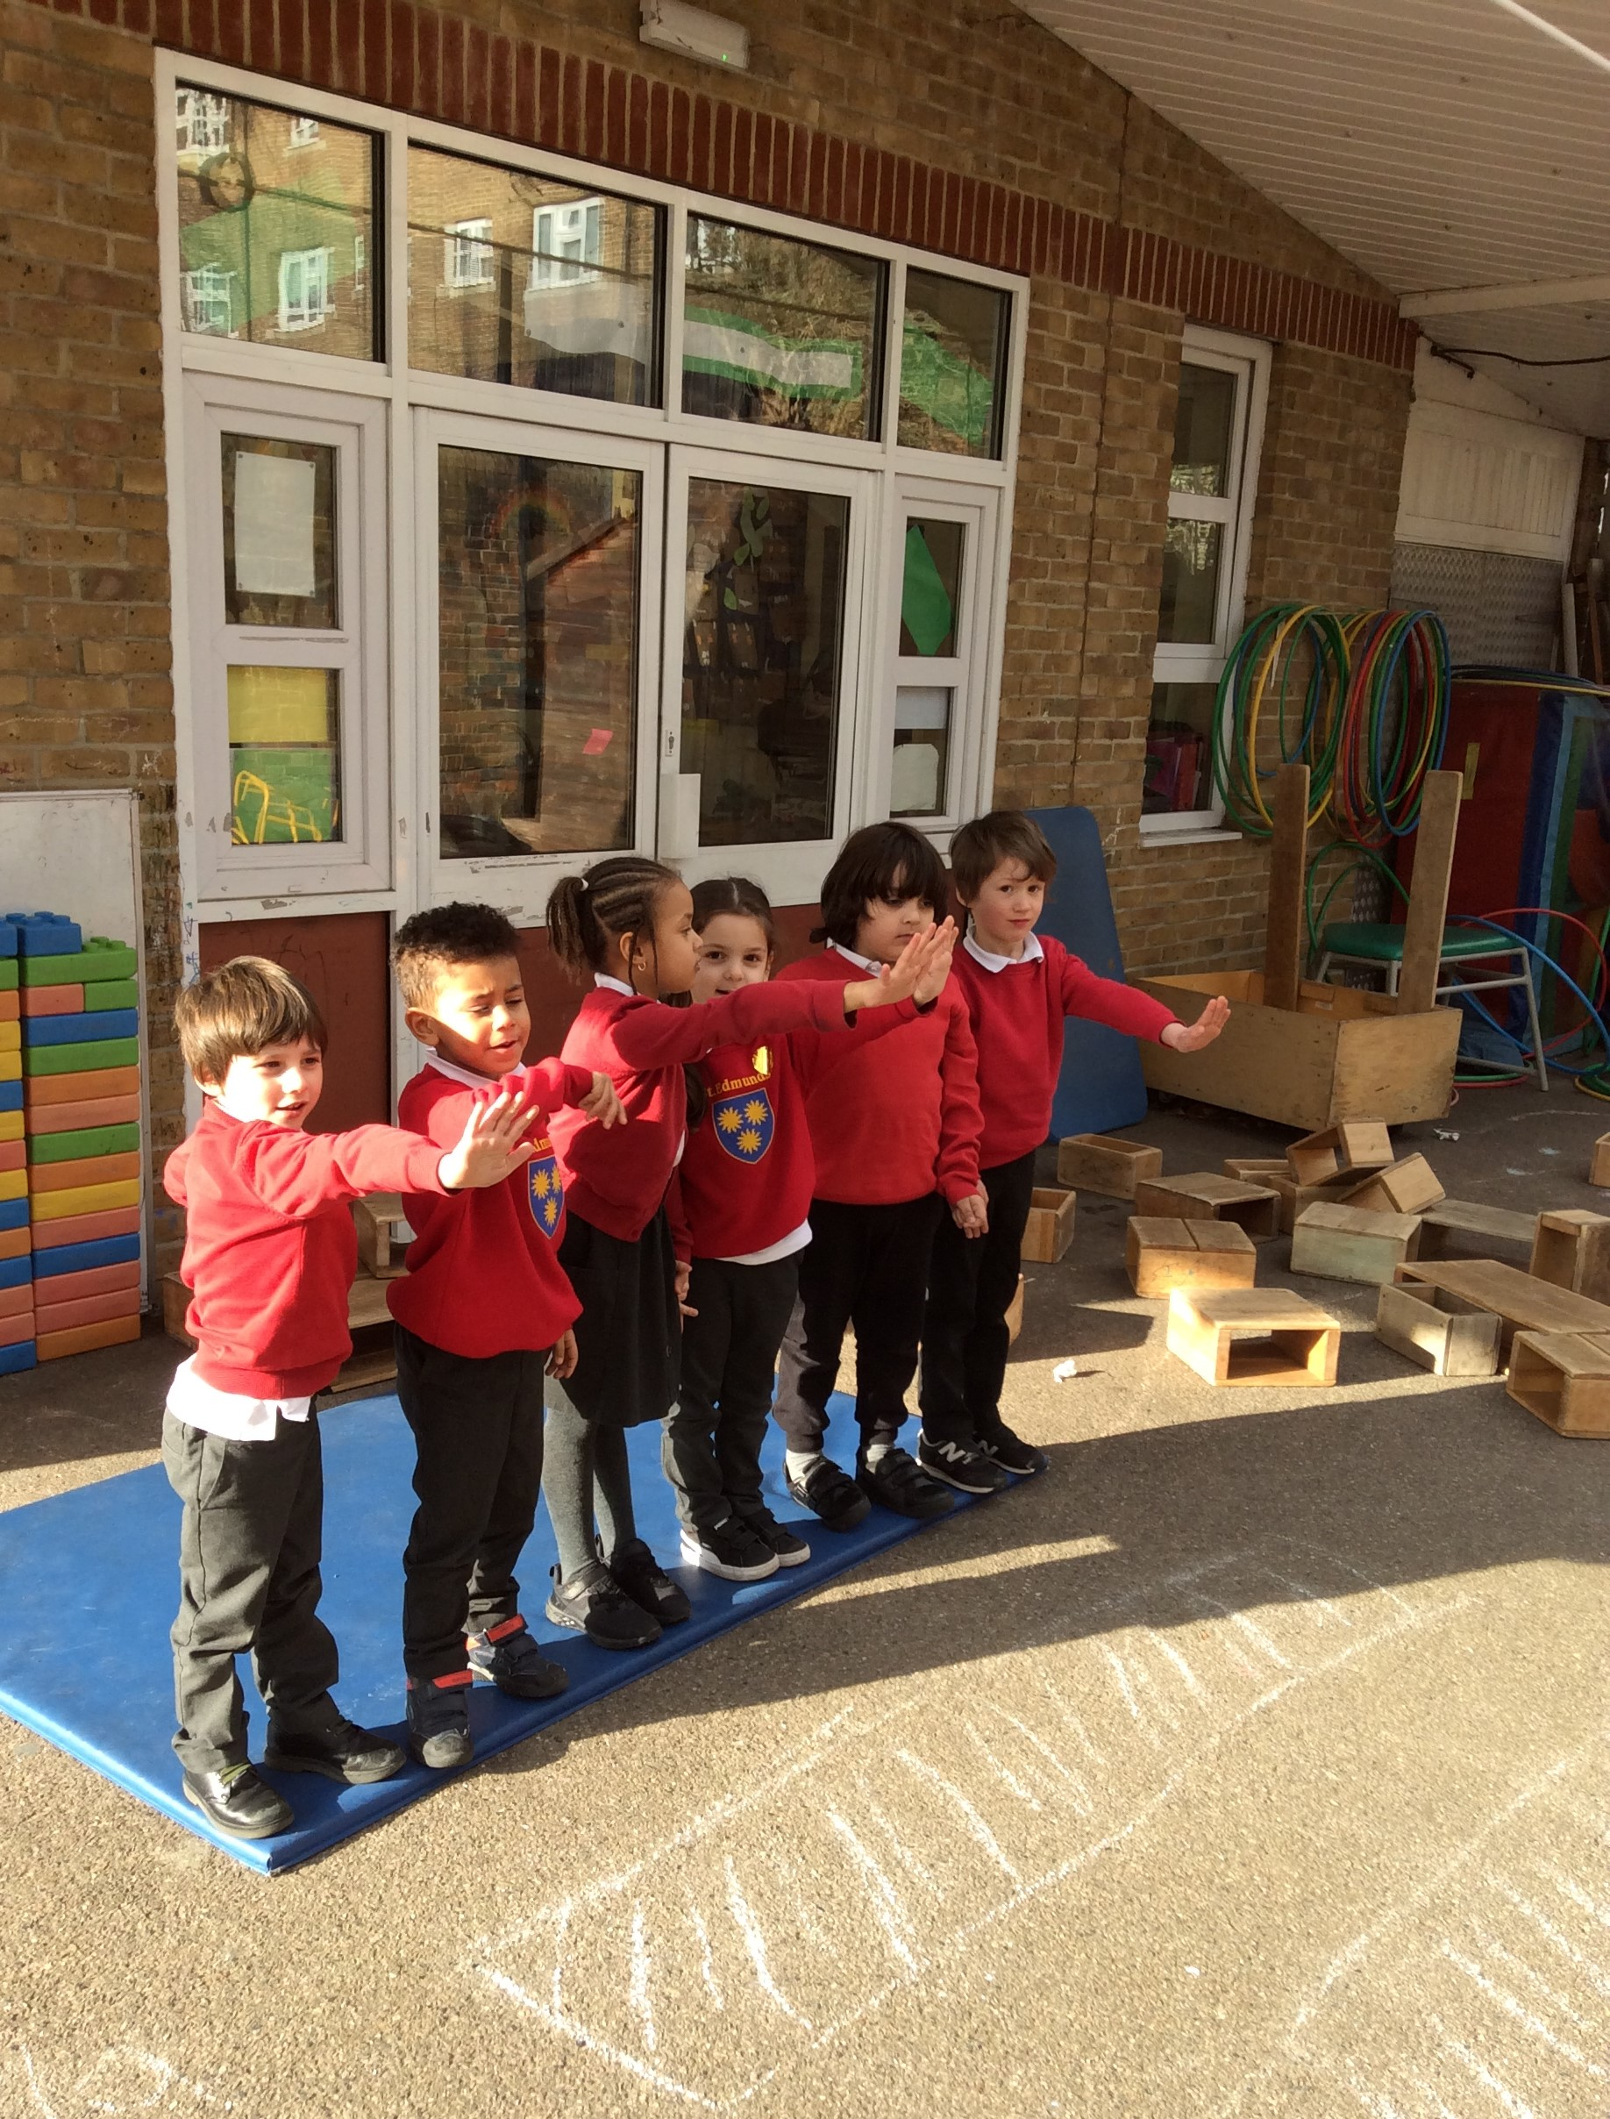
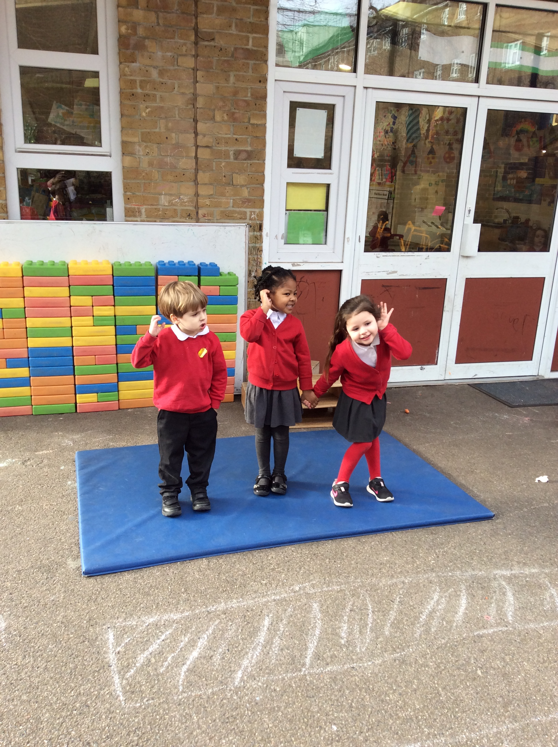
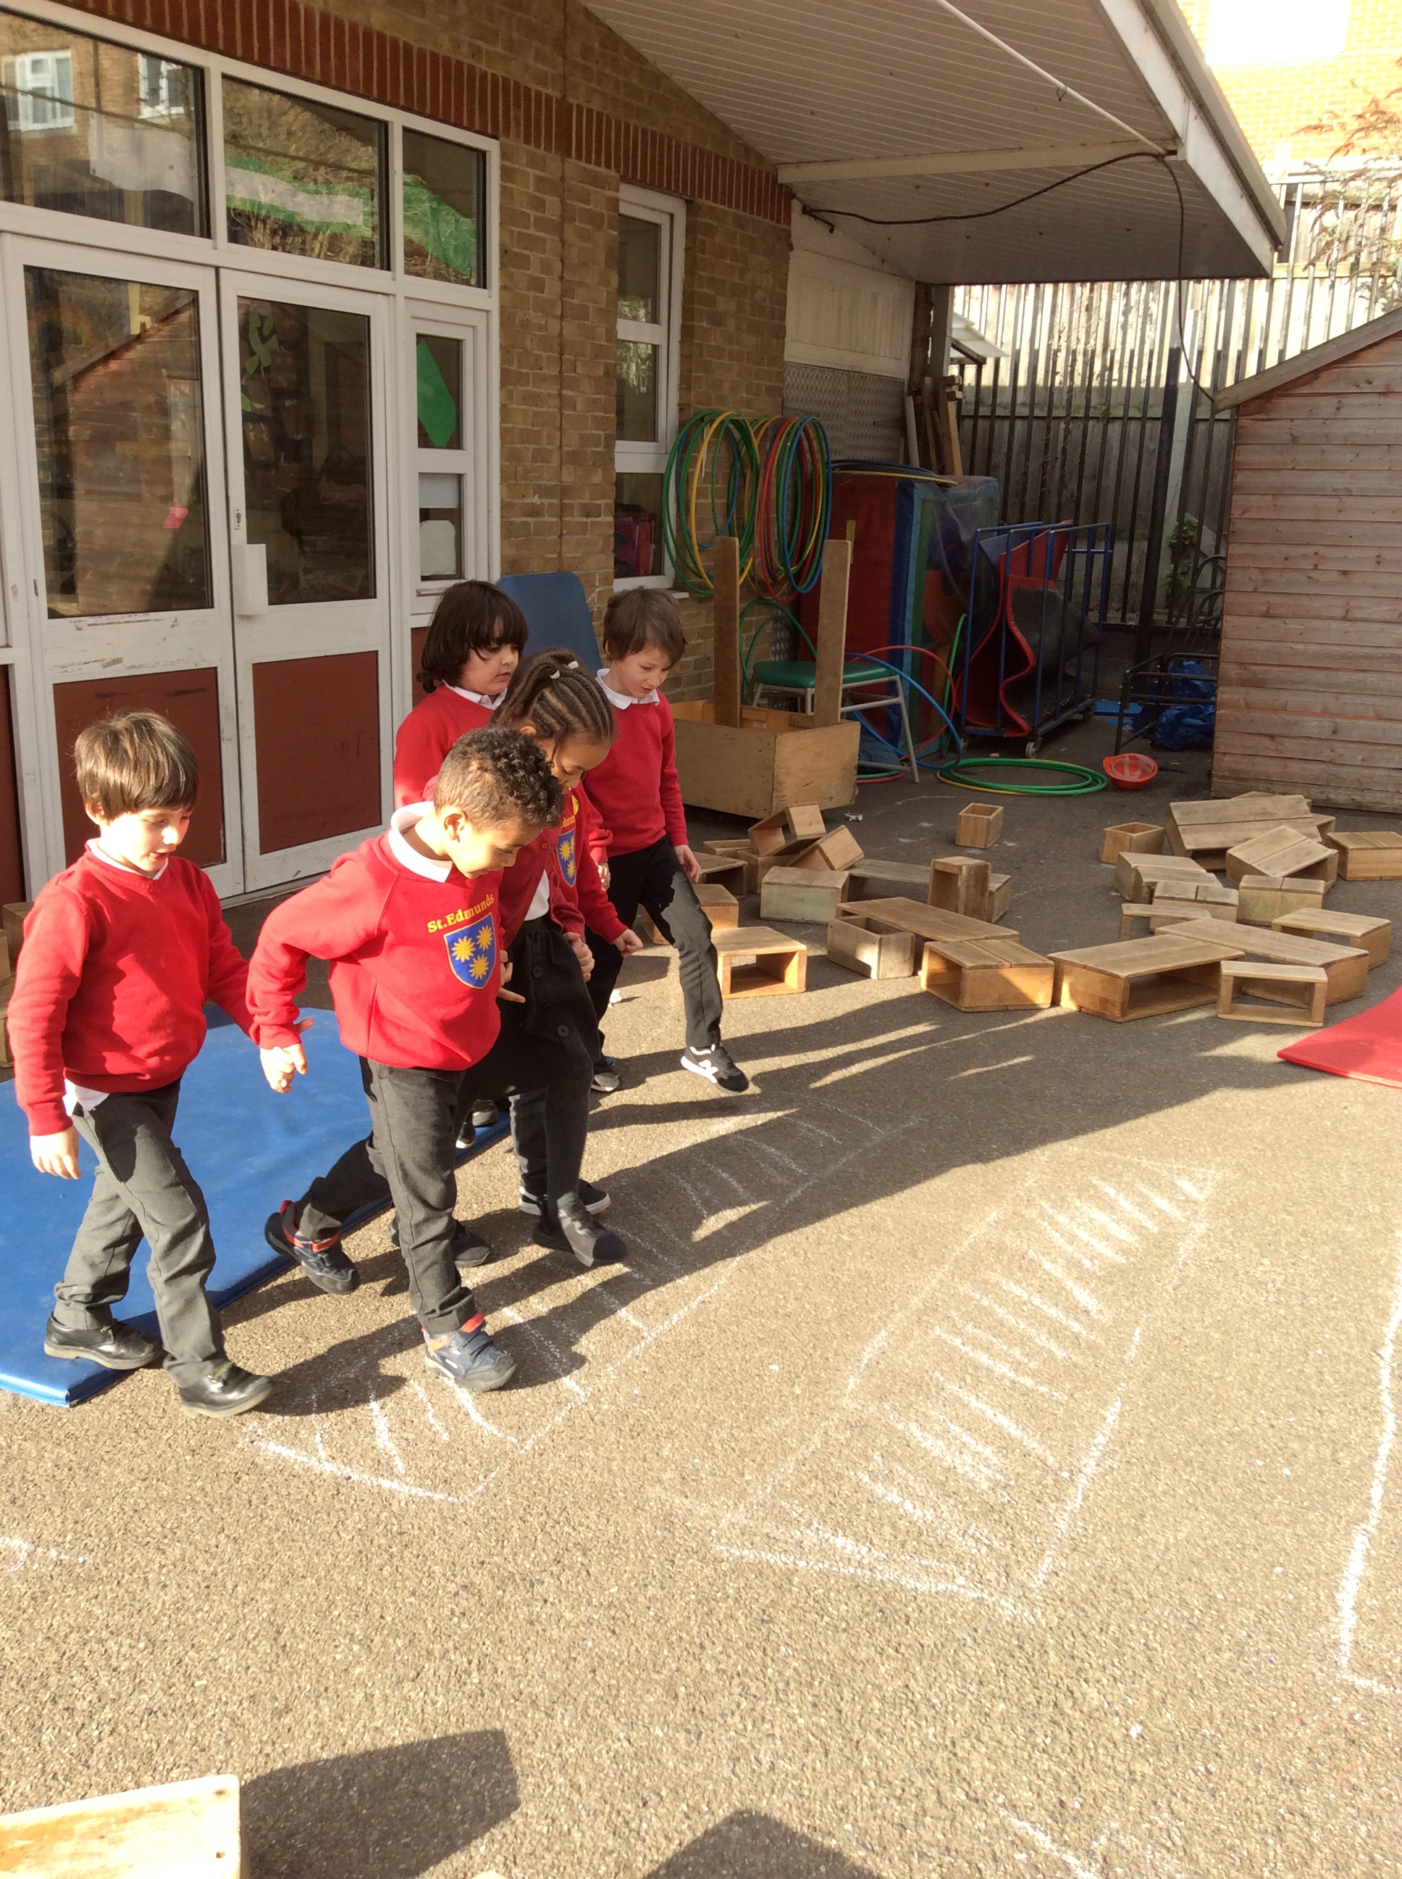

‘Children in Early Years enjoying a lovely outdoor activity using the space and resources in a new set up’

Year Two trip to St Paul’s Cathedral
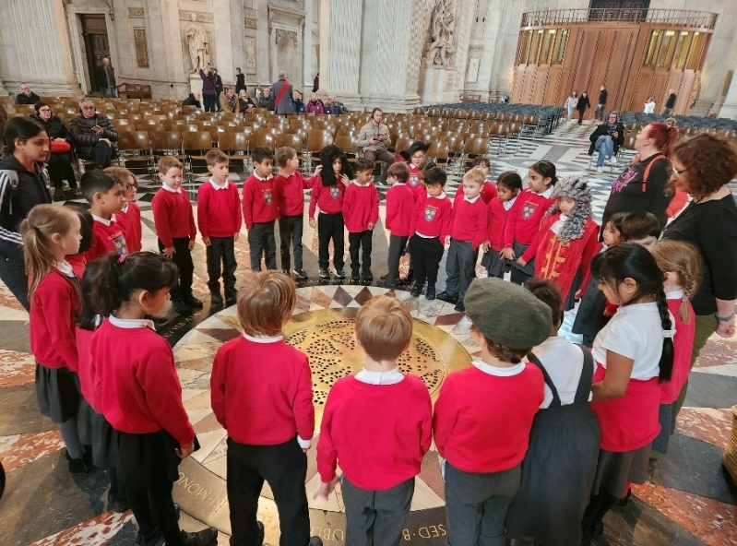  Year 4 admired the architecture inside the Cathedral. | 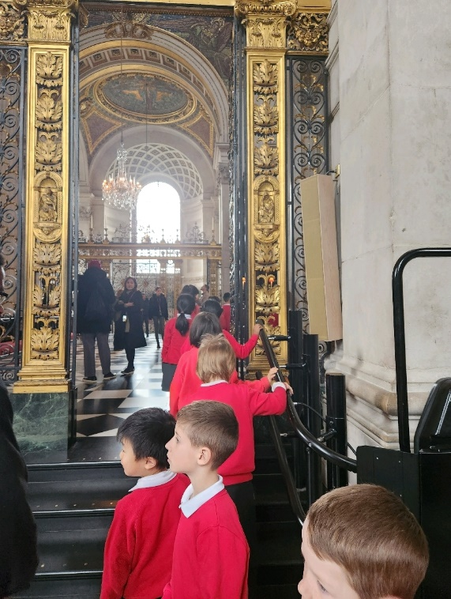
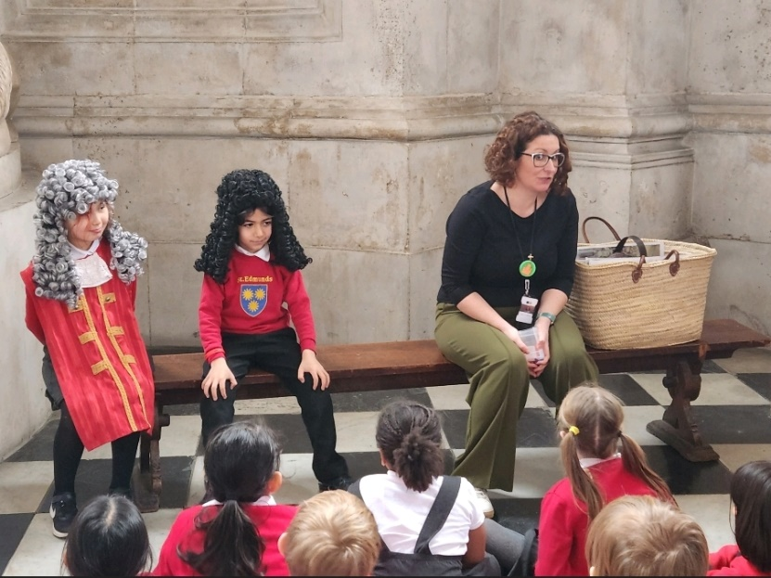  We acted as King Charles II and Samuel Pepys. | We tried to locate St Edmund’s School from the top of the Cathedral!  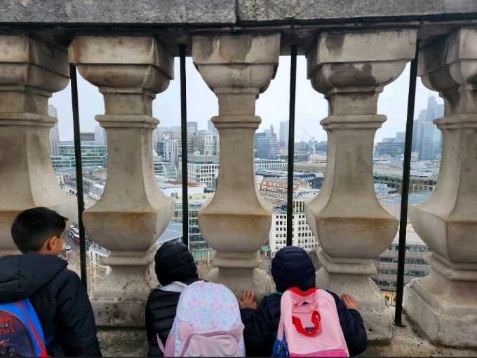

Bank Holiday  Due to the King’s Coronation, there is an extra Bank holiday on Monday 8th May 2023. School will be closed on this day. School resumes on Tuesday 9th May. |  | Sports Day  Our annual Sports Day, which is usually held in May, will now take place on Thursday 13th July. A new House Team system will be introduced; this is creating lots of excitement amongst the children! Please see the sheets in the display cabinet in the playground for your child’s House Team. More details to follow nearer the date.

‘The kids at cooking club were making oat cookies and made a chef hat last week.’
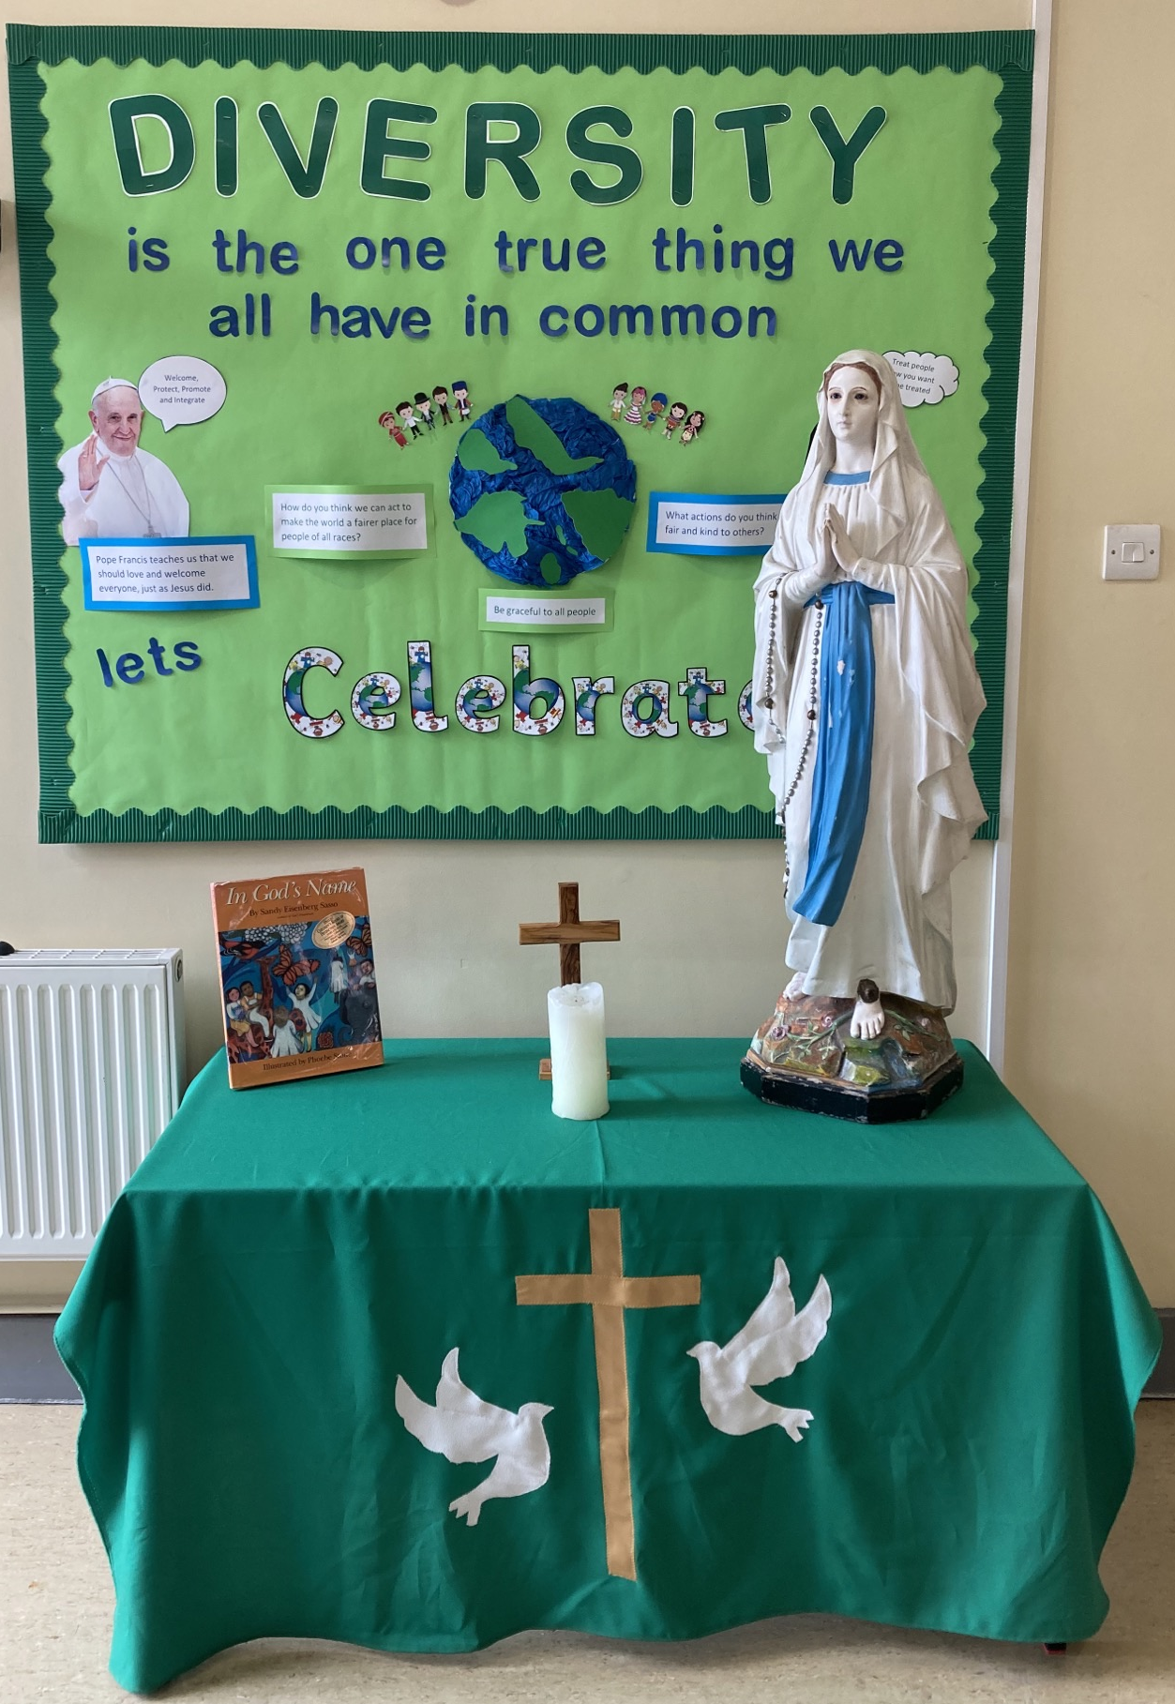

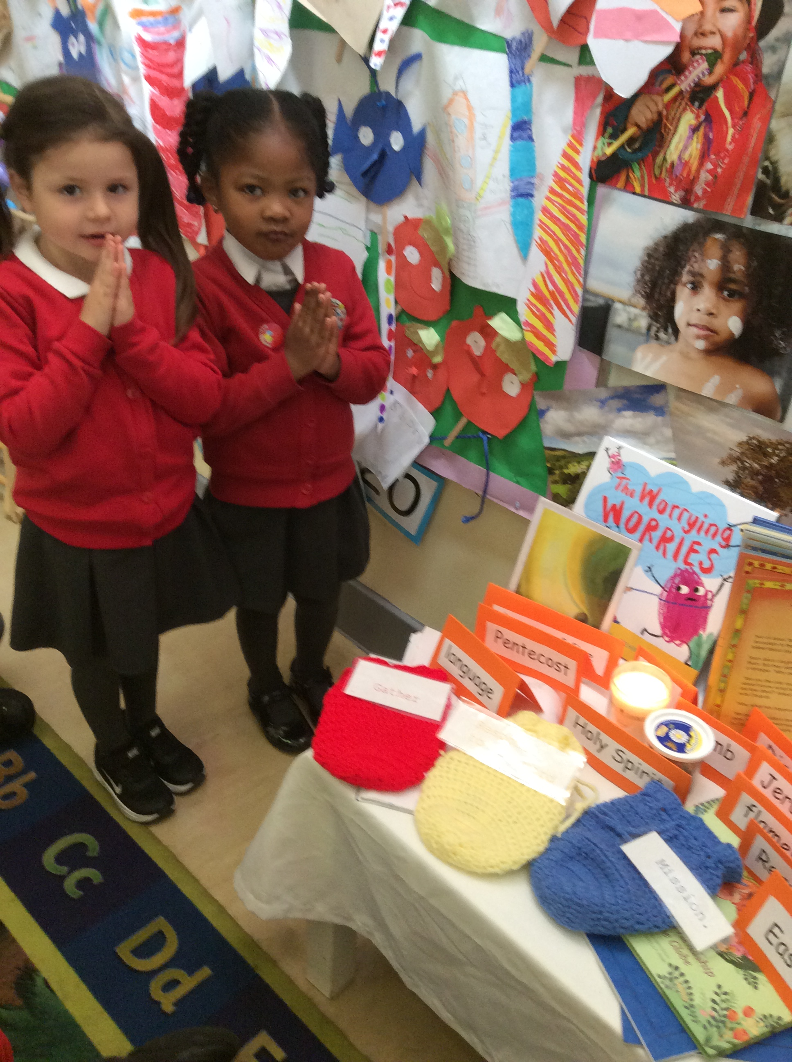
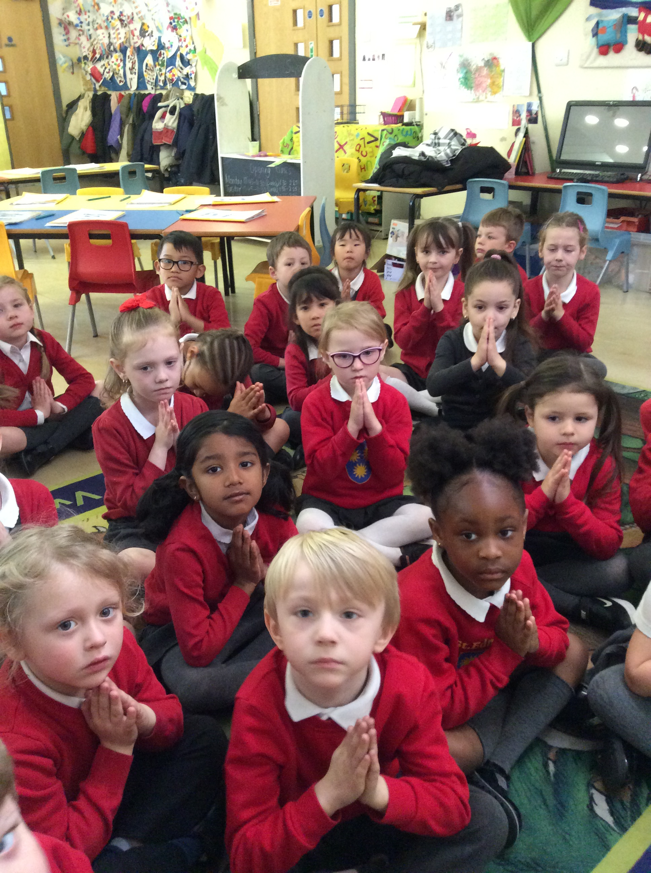
‘We are very proud of our new Prayer Table in the Reception office area. Please bear with us as we are updating the space with new displays and other features’

‘Children during their Collective Worship in class praying’

