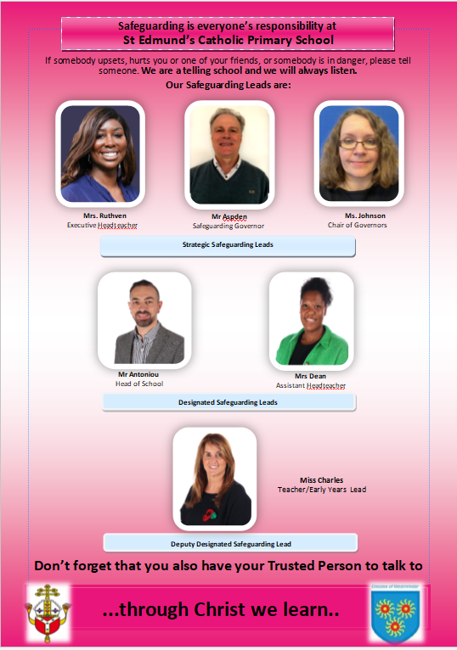


Welcome to St Edmund’s Catholic Primary School
At St Edmund’s, we are committed to creating a happy, safe, and inclusive environment for all our children. This leaflet outlines our safeguarding practices to help you understand your responsibilities and the measures in place to keep our pupils safe.

What You Need to Know About Safeguarding
Safeguarding is everyone’s responsibility. All schools are required by law to have arrangements in place to safeguard children and promote their welfare. At St Edmund’s, we:
- Ensure all staff, regular visitors, and volunteers follow our safeguarding policy.
- Work closely with children, families, and external agencies to protect children from harm.
- Provide staff with regular safeguarding training to identify and respond to concerns effectively.
A copy of our safeguarding policy is available on our school website or from the school office.

What Does This Mean? What Concerns May We Have for Your Child?
- If your child has said something worrying to us, for example, if they tell us they have been intentionally hit with an object.
- If someone at school sees an unusual or unexplained mark or injury.
- If their behaviour is particularly out of the ordinary.
- If it has been reported to another agency that something has been said or witnessed by your child.
- Or, if there are any other reasons we feel your child may be suffering harm outside of school, we have a legal duty to make a referral.
If possible, we will discuss the referral with you and let you know it has been made. However, sometimes social services ask us not to talk to you. They may do this if they feel your child may be put at more risk by informing you. It is always better for your child if we can work together.
We understand that you may feel angry, upset, or worried because we have made a referral. The decision to make a referral is never taken lightly. However, every member of staff or volunteer that works at every school has a duty to act in the best interests of children at all times. This means acting quickly to reduce any risks where a child’s safety is of concern. (UNCRC: Article 24)

Types of Harm
Children can experience harm in several ways. It is important to recognize these signs to help protect them:
- Physical Abuse: Deliberate harm or injury, including physical punishments. Hitting a child with an object or leaving marks is not acceptable.
- Emotional Abuse: Making a child feel worthless, frightened, or unloved through threats, insults, or witnessing violence.
- Sexual Abuse: Forcing or influencing a child to participate in sexual activities, including exposure to inappropriate images.
- Neglect: Failing to meet a child’s basic needs, such as proper hygiene, diet, or medical care.

Key Safeguarding Contacts at St Edmund’s
- Designated Safeguarding Lead (DSL): Mrs Ruthven, Executive Head Teacher, Mr Antonis Antoniou (Head of School), Mrs Paulla Dean (Assistant Head Teacher)
- Deputy Safeguarding Leads (DDSLs): Ms Maria Charles (EYFS Lead)
- Named Governor for Safeguarding: Mr. Philip Aspden
- Chair of Governors: Ms. Magdalena Johnson
If you have any concerns about a child’s safety or welfare, please contact the DSL or a member of the safeguarding team immediately.

If You Have Concerns
As a visitor to our school, you may notice something that concerns you, such as:
- A child showing signs of harm (e.g., bruises, unusual behaviour).
- A child disclosing something concerning.
- Behaviour from an adult that causes unease.
What to Do:
- Do not ignore your concern.
- Report it immediately to the DSL or Deputy DSL.
- Do not promise confidentiality to the child; explain that you need to share the information to help keep them safe.

Our Commitment to Keeping Children Safe
At St Edmund’s, we:
- Conduct thorough checks on all staff, volunteers, and regular visitors to ensure they are safe to work with children.
- Train our Designated Safeguarding Leads to respond appropriately to safeguarding concerns.
- Teach children about keeping themselves safe through lessons on online safety, healthy relationships, anti-bullying, and more.
- Provide a safe and welcoming environment where children feel confident to speak about their worries.

What Visitors Must Do
- Wear your visitor’s badge at all times while on the school premises.
- Sign in and out at reception and follow our safeguarding procedures.
- Avoid taking photographs or recording videos of children.
- Do not initiate physical contact with children.
- Report any safeguarding concerns to the DSL or Deputy DSL immediately.

Working Together to Safeguard Children
We understand that safeguarding is a shared responsibility. Together, we can create a secure and nurturing environment for every child at St Edmund’s Catholic Primary School.
For further information, please refer to our safeguarding policy on our website or contact the school office.

Thank you for helping us keep our children safe!

