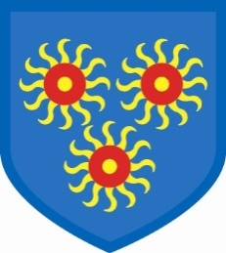
St Edmund’s Catholic Primary School
Diocese of Westminster
www.st-edmunds-school.org
Follow us on @stedmundsschoo1
Parents Newsletter 8th October 2019
DIARY DATES

Monday 14th October & Tuesday 15th October: Parents Consultations with teachers.
Please book your appointment online. If you have lost your password, please see reception for a replacement.
Friday 18th October: Last day of the half term.
Monday 28th October: Children return to school.

Class assemblies
Friday 11th October – Year 3
Friday 18th October – Year 2
Friday 8th November – Year 1

Non-Uniform Day
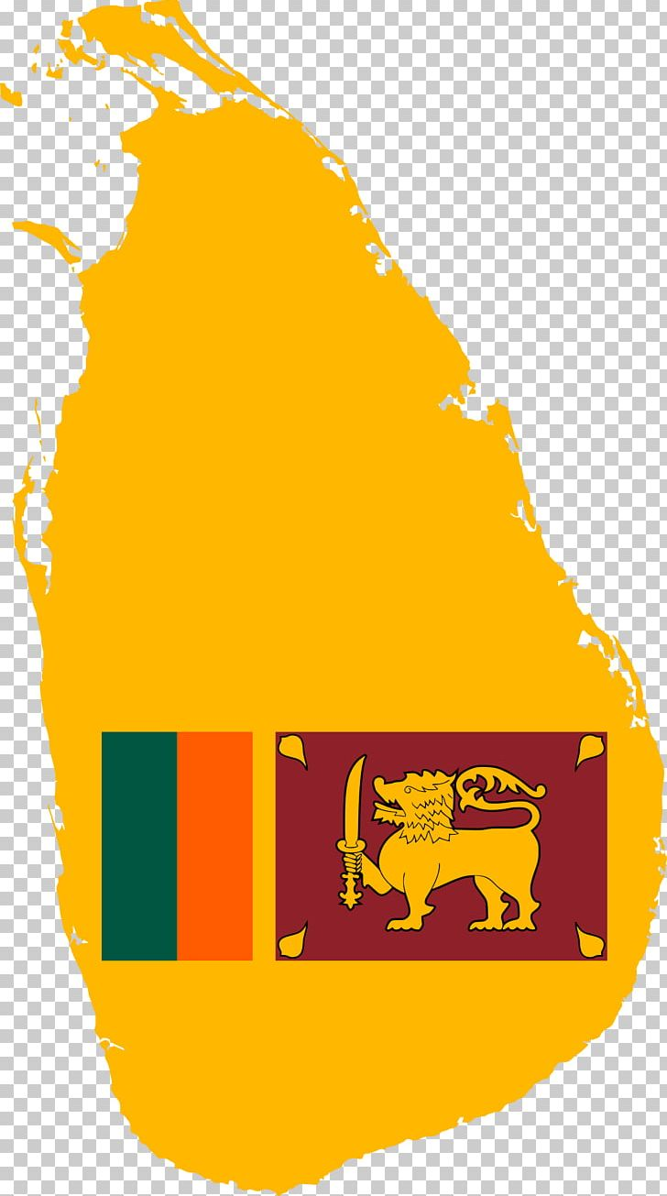
The last day of the half term, Friday 18th October is a non-uniform day. The money raised will go towards helping the victims and families of the Sri Lanka churches and hotels terrorist attacks in April. Altogether, 259 people were killed and over 500 were seriously injured. Your donations will be greatly appreciated by those who have suffered.

Book Fair
Our book fair will be open from 3.15-4pm on Thursday 10th of October, Friday 11th, Monday 14th and Tuesday 15th.

Welcome
A big, warm welcome to all the new families who have joined St Edmund’s School.

Student Update Forms
If you have not returned your student information update forms, please hand these into the reception desk. Amongst other things, the information you provide on these forms is vital for when the school needs to contact you.

Governors Fund
The Governors’ Fund envelopes have been sent out. Thank you to those who have returned them so far. Please check in your child’s book bag if you have not received yours.

Packed Lunches
If your child has a packed lunch can you please confirm with reception so that we can plan and cook the correct number of school dinners thus avoiding waste.
p

Football tournament

Well played to all the children who represented our school, at the George Greens’ School football tournament last Friday. St Edmund’s came 3rd out of 7.

