Diocese of Westminster
ST EDMUND'S CATHOLIC PRIMARY SCHOOL
Supplementary Information Form 2024– 2025
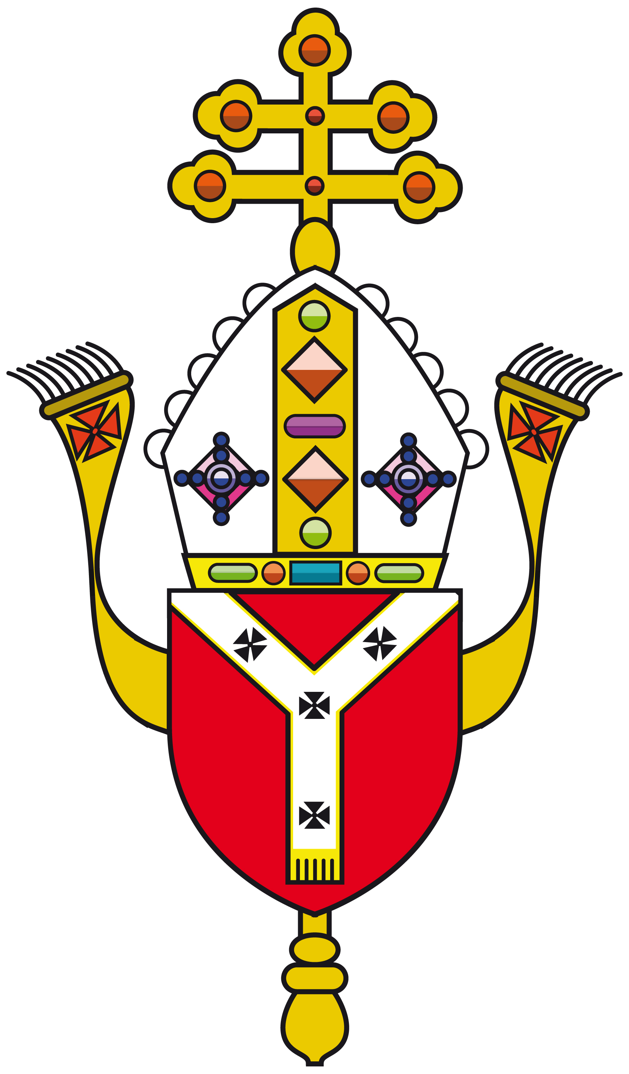

Name and Address of School:
St Edmund’s Catholic Primary School
299 Westferry Road, London E14 3RS

Child’s Details
Child’s surname:
Child’s first name:
Home Address: | Date of Birth:
 | Postcode:

Parent/Carer Details
Parent‘s name:
Address (if different from above):
Telephone number:

Details of Religion
Religion of child:  (Please tick) | Catholic | Other Christian (name of denomination ) | Other faith
Catholic Parish you live in:
Church where child was baptised and date of baptism: (baptism certificate required)

Name and position of priest or religious leader supplying reference (where appropriate) :

I confirm that I have read and understood the Admissions Policy and that the information I have provided is correct. I understand that I must notify the school immediately if there is any change to these details and that should any information I have given prove to be inaccurate that the governors may withdraw any offer of a place even if the child has already started school.

Signed……………………………………… Date…..…………………

Please note:
- Where applicable parents can obtain a Certificate of Catholic Practice Form from the parish office or from the Diocese of Westminster website.

- Applicants from other Christian denominations and other faiths may attach a letter, confirming membership, from their minister or religious leader.

- You must complete your local authority’s Common Application Form and return it to the council offices by the closing date. If you do not do this you will not be offered a place.

Checklist:

Have you enclosed:

Copy of baptism certificate

Certificate of Catholic Practice (where necessary)

Evidence of exceptional need (where necessary).

Have you completed your local authority’s Common Application form?

