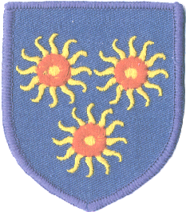
St Edmund’s Catholic Primary School
Diocese of Westminster
www.st-edmunds.towerhamlets.sch.uk
Follow us on @stedmundsschoo1

Newsletter to Parents Friday, 10th September

Class assemblies
These will continue to be filmed and uploaded online for you to view. Parents will be informed when their class is due to have an assembly.

Drop off and pick up times
Here is a reminder of the times for you:
Year 6: 8.55am – 3.30pm (football pitch gate)
Year 5: 8.55am – 3.30pm (school gate)
Year 4: 9.00am – 3.25pm (football pitch gate)
Year 3: 9.00am – 3.25pm (school gate)
Year 2: 9.05am – 3.20pm (football pitch gate)
Year 1: 9.05am – 3.20pm (school gate)
Reception: 9.10am – 3.15pm (football pitch gate)
Nursery: 9.10am – 3.15pm (school gate)

We would like to wish you all a warm welcome back after the summer holidays. We hope that you have all had a happy and safe summer and that your children are looking forward to the new term! We will be continuing with most of our current restrictions until we are through the winter period.

  St Edmund’s Credit Union is open every Wednesday from 8:45 – 9:00am. Come along and start an account.  SEFGA  The last SEFGA meeting had a brilliant turn out. Thank you all for the support. The next meeting will be on Tuesday 15th October at 9:00am.  CLASS ASSEMBLIES  Changes to Class Assembly dates.  4th October- Year 4  11th October-Year 3  18th October- No Assembly  25th October - Year 2  Assembly starts at 10.10 a.m.    Just a reminder to book places for our breakfast club and after school club via our website. You can order jumpers and bookbags from our website too. | School Uniforms  We understand that there is some difficulty with uniforms not being delivered to shops at the moment. We will therefore accept children coming to school with plain grey or black trousers, a white top, a plain red jumper and black shoes whilst this resolves.  Child information forms  These will be going out shortly. In the meantime please let us know of any changes to phone numbers or any other information. Thank you.  .    

