

St Edmund’s RC Primary School
Diocese of Westminster

Newsletter to Parents 25th January, 2019
CLASS ASSEMBLIES  1st February – Year 2  8th February – Year 1  15th February – Reception Class  Assembly starts at 10.10 a.m. in the Hall.  After-School Clubs    After-school club places have now been allocated for the Spring Term. If your child has not been given a confirmation slip, they will be put on the waiting list for a place. Please note that when a club consists of two year groups there is the potential for 55-60 children applying for that particular club, when there may be just 12 places available. We attempt to make the allocation as fair as possible. Thank you for your understanding.  Dates For Your Diaries  March 4th & 5th – Parent conferences.  February 18th to 22nd – Half term holiday.  Monday, February 25th -School re-opens for the next half term. | CLASS MASSES  1st February – Year 4  8th February – Year 3  15th February – Year 6  Mass starts at 9.15 a.m. in church.    A big thank you to all the children, who were able to raise £1,300 for The Passage as part of our Advent Appeal. Thank you to everybody for your generous sponsorships.    KS2 Fruit  Children in Key Stage 2 are allowed to bring in a piece of fruit or a vegetable to eat in school as a snack. Please do not bring anything that requires preparation, or anything that isn’t simply a piece of fruit or a vegetable.

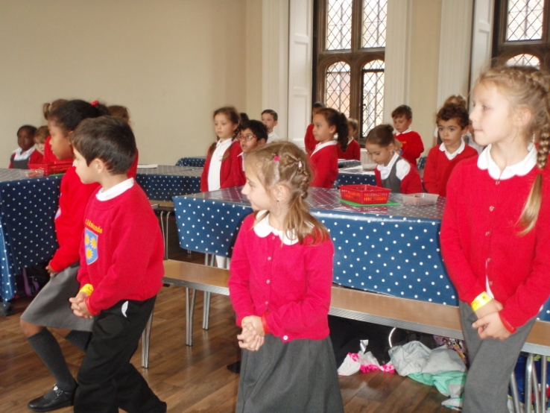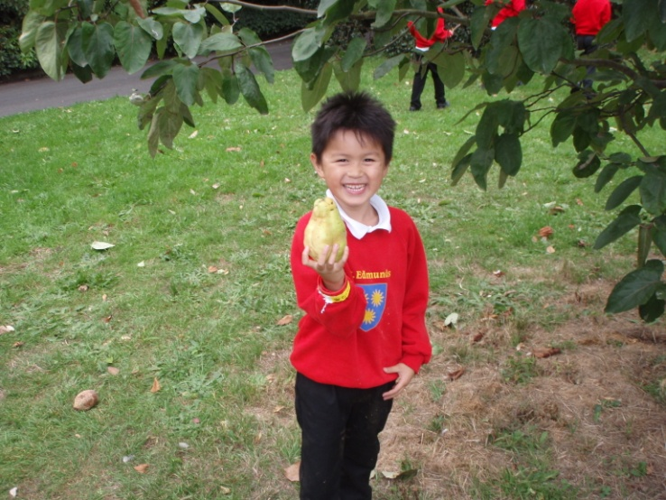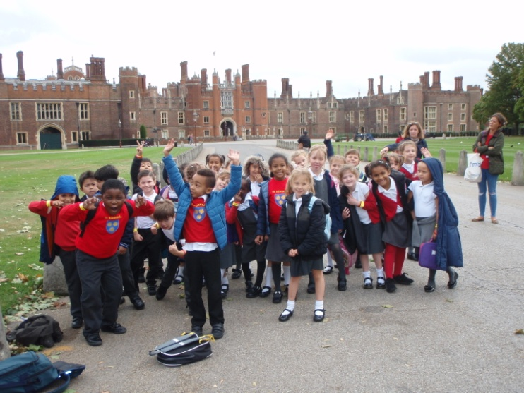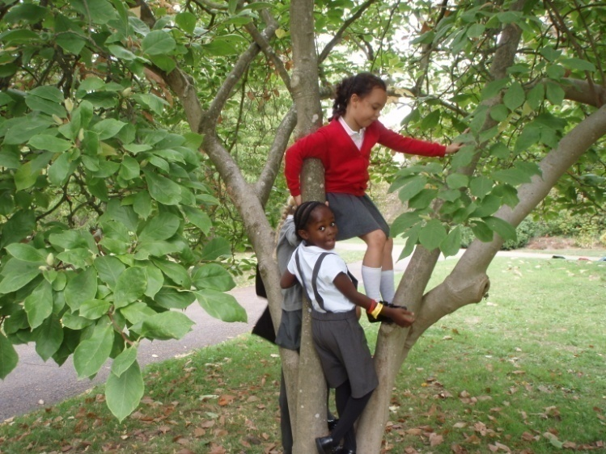
We are pretending to be Tudor ladies and gentlemen.
This is a Quince!
We’re relaxing in the grounds of a Tudor stately home.
Year 2’s visit to Hampton Court Palace last term.
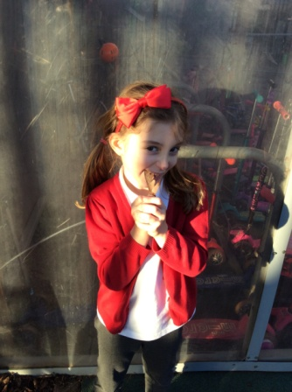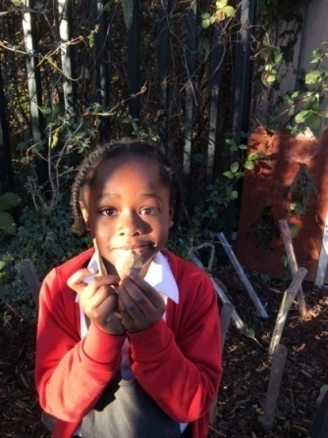
A leaf reminds me of God because leaves make oxygen which we need to live.
Stones and sticks remind me of God because they are strong.
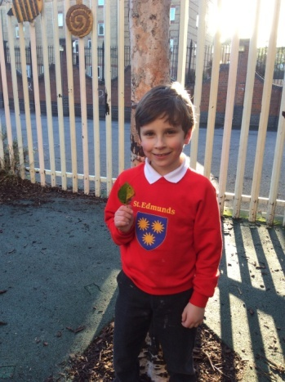
Year 2 were looking at where we might find God in nature.

A leaf reminds me of God because a leaf grows and I grow. Both created by God.

