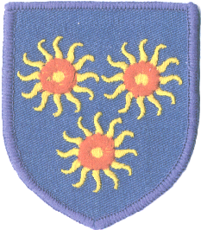

St Edmund’s Catholic Primary School
Diocese of Westminster
www.st-edmunds-school.org/website
Follow us on @stedmundsschoo1

Newsletter to Parents Thursday, 6th October 2022
Year Two Learning
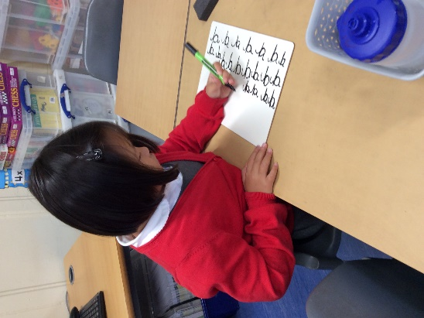
We are practising our cursive handwriting.
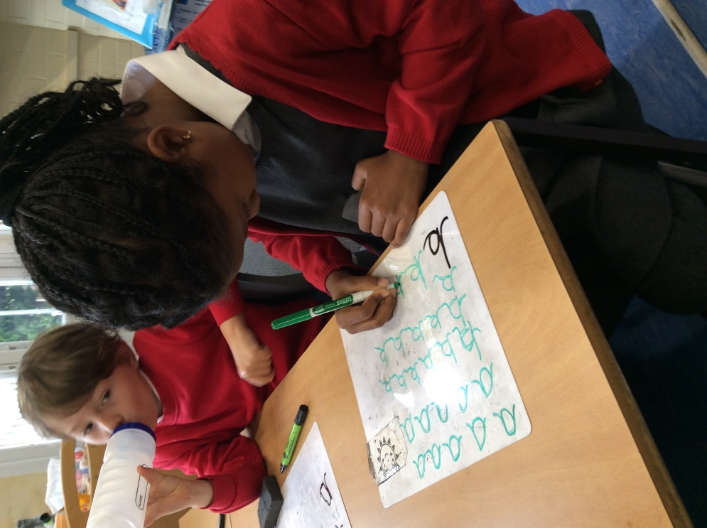

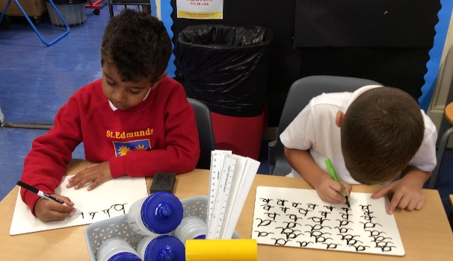

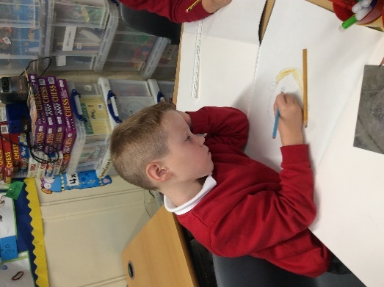
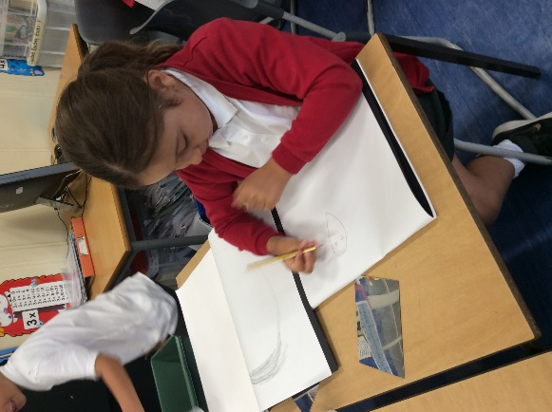
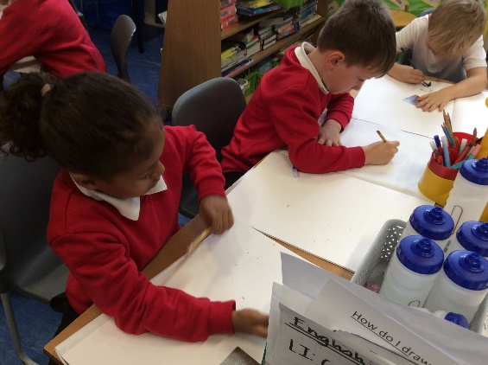

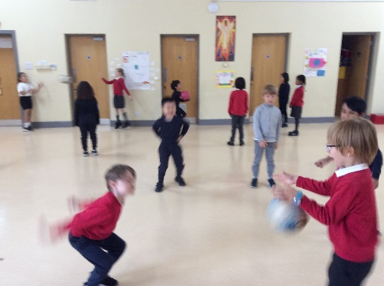
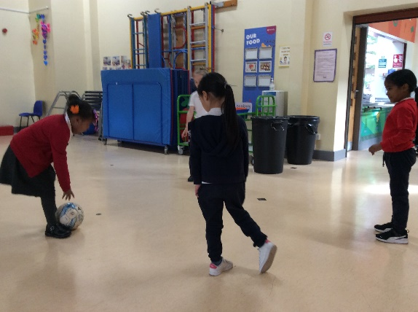
For PE we are learning how to control the ball, using our hands and feet.
For our Art topic, we have been learning about famous portraits and drawing our own!
Class Assemblies
Here are the dates for the upcoming class assemblies:

Thursday, 13th October: Year 3
Thursday, 20th October: Reception
Assemblies start at 10.10am in the hall and finish by 10.30am.

What do our students say about their learning?
Y2 –I have liked the different kinds of Maths, counting in 3s-Antonis.
Y2 – Good!-Michael
Y2-I like when we do our faces in Art!-Milan
Y2-We get to learn a lot of things.
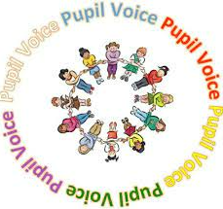

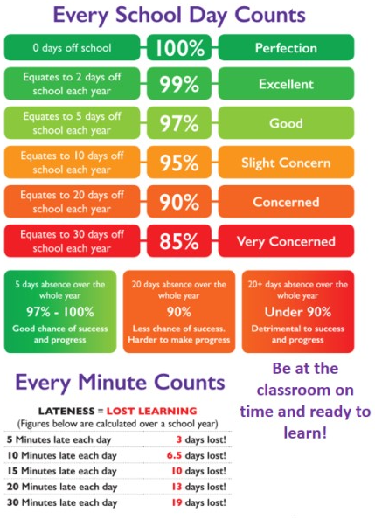
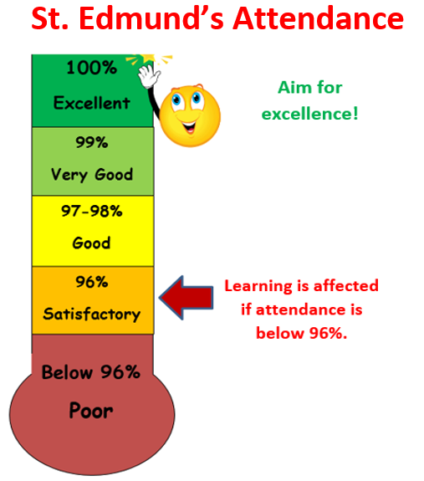

Our target it to get our attendance back up above 96%.

Whole School Attendance – 93.71%
Best Class Attendance
23rd September – Nur – 100%
30th September – Reception – 98.66%
6th October – Year 4 – 96.92%

Each week we will be sharing and celebrating the class with the highest attendance or the most improved attendance.
The class that achieves this award will make healthy smoothies. We understand that some children are unable to attend school every day for various reasons, and we will continue to support them and celebrate their attendance too.

St. Edmund’s Safeguarding Information

Safeguarding
Safeguarding and keeping our children safe are very important to us. If you have any suggestion on how we can improve on our safety measures, please do speak with Mrs Savva-Brown.
If you have any concerns about any child’s safety or child protection, please see
Mrs Savva-Brown, the school’s Designated Safeguarding Lead – Headteacher ASAP.
If she is not available, please see another member of the safeguarding team.
There are photographs of the Safeguarding team placed in each classroom, please talk to your children and encourage them to talk to the adults in school if ever they need to.
For information on Safeguarding, please see the Tower Hamlets multi-agency safeguarding hub website.
https://www.towerhamlets.gov.uk/lgnl/health__social_care/children_and_family_care/Multi-Agency-Safeguarding-Hub-MASH.aspx

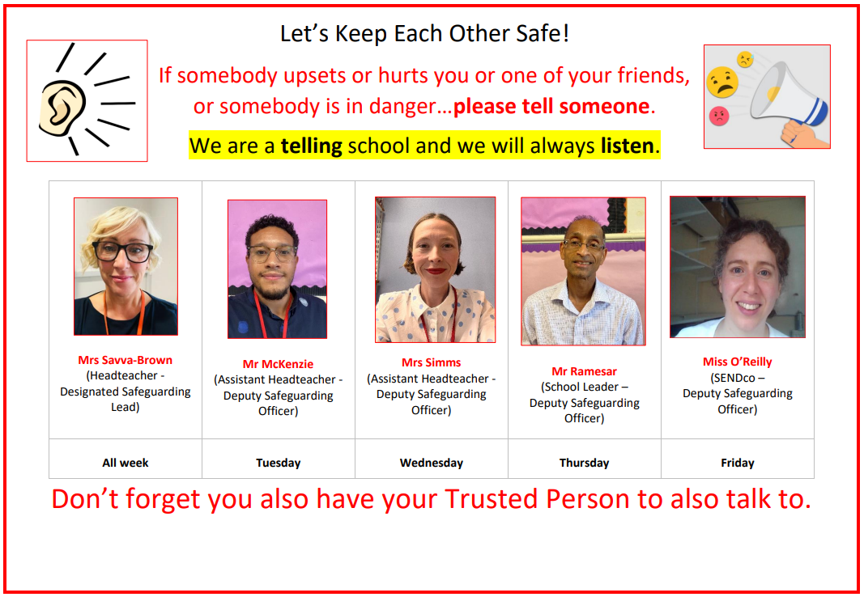
What do our students say about safeguarding?
Y2 – We have the poster on our door!-Hazel
Y2 –If you tell them someone is in danger, they’ll know what to do!-Lawrie

Elected School Councillors
We would like to congratulate our newly appointed school councillors for this year! They are:
Year 6: Jonathan & Enara
Year 5: Joey & Sophie
Year 4: Anna & AJ
Year 3: Amy & Dudley
Year 2: Vanessa & Milan
Year 1: Pranav & Siya
Reception: Alice & Mateen

