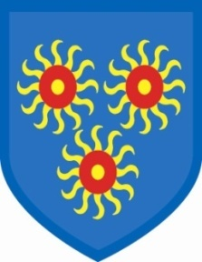
St Edmund’s Catholic Primary School

22nd October, 2021
Dear Parents/Carers,

I am happy to say that all the measures we have reintroduced for Covid appear to be working. We have had no cases reported this week. However, please remain vigilant, as we are in school. There is a new strain that is seeing numbers of confirmed cases rise swiftly and the number of people admitted into hospital is also on the rise.

Several parents are sending their children into school after giving them Calpol. This is an indicator that you know that something is wrong with your child. We do not have facilities to look after sick children, so please do not send them in if you have had to give them medicine. I will say again, if the staff sickness reaches a critical number we will have to close the school. We all have to support each other at this time, so please think carefully and keep sick children at home.

Next week is half-term. We have sent you an email with leaflets of activities happening in Tower Hamlets for the week. When we return, we will be holding parents’ conferences on Monday 1st, Tuesday 2nd, Wednesday, 3rd November, with some teachers also holding conferences on Thursday, 4th. If you have not been able to sign up for a suitable time, please contact Jo Hannan or Shenaya to organize another appointment.

I want to thank you for how you line up at the school gates. This was slightly chaotic at the beginning, but you all seem to have sorted yourselves out! The staff really appreciate how quickly we can get the children in and out of school.

Finally, have a great half-term break, whatever you are up to. I am off to lie down for a week!

See you on Monday, 1st November.

Gail O’Flaherty

