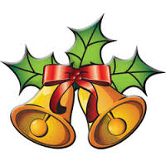
CHRISTMAS TIMETABLE

Sunday, 22ndDecember 2019 Fourth Sunday of Advent
Masses at 6pm, Saturday & 9am & 11am Sunday
Confession on Saturday - 5pm – 5.45 pm

Tuesday, 24th December 2019 Christmas Eve
6.30pm Children’s Mass for Christmas
11.30pm Christmas Night Carol Service &
Midnight Mass of Christmas

Wednesday, 25th December 2019 Christmas Day
11am Mass of Christmas Day

Thursday, 26th December2019
11 am Mass of Altar Servers
Friday, 27th December No Mass

Sunday, 29st December The Holy Family of Jesus, Mary and Joseph
Masses at 6pm, Saturday & 9am & 11am Sunday

30th December 2019 No Mass
31st December 2019 11 am Mass
1stJanuary 2020 11 am Mass
2nd/3 rd January 2020 No Mass

Sunday, 5th January 2020 The Epiphany of the Lord
Masses at 6pm, Saturday & 9am & 11am Sunday

From 6th January2020 all Masses at usual times

