St Edmund’s Catholic Primary School

Curriculum Content Skills and Knowledge Progression Document

2025/26
SCHOOL MISSION STATEMENT
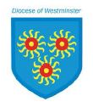
…through Christ we learn…

Year 1 – Branch 1 – Creation and Covenant
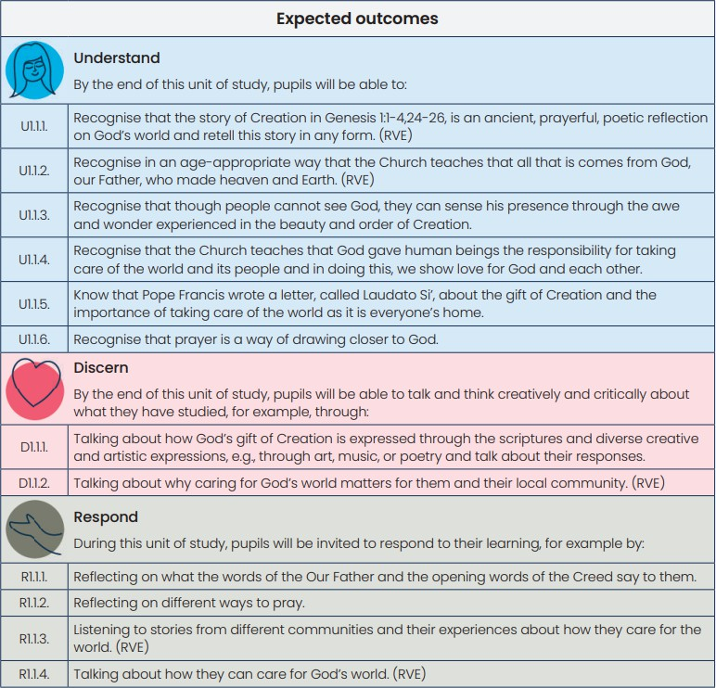
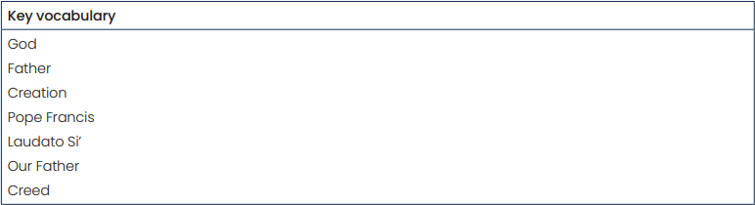

Year 1 – Branch 2 – Prophecy and Promise
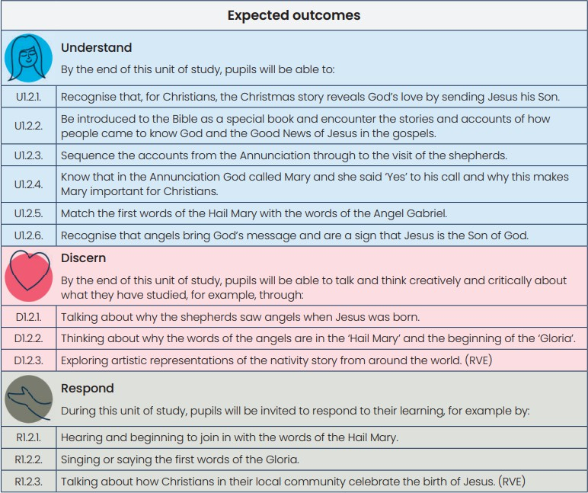
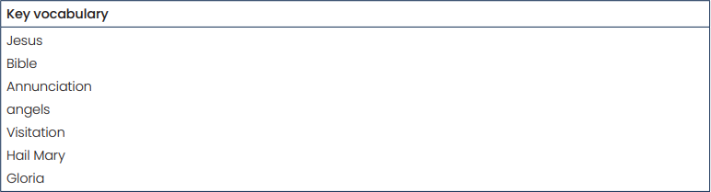

Year 1 – Branch 3 – Galilee to Jerusalem
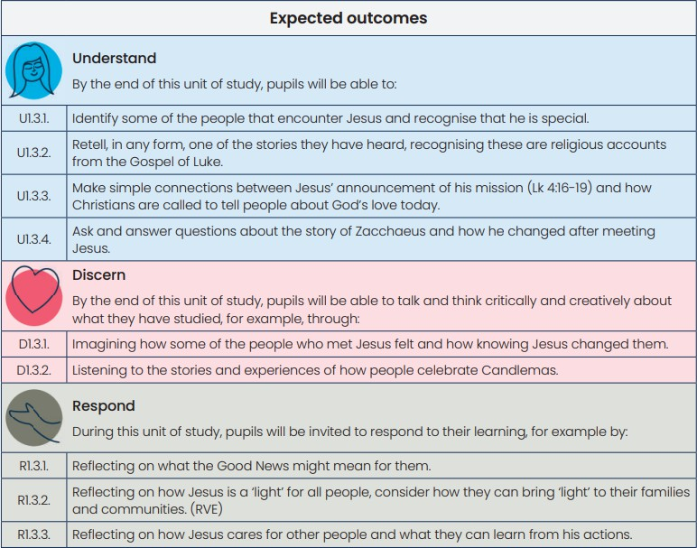
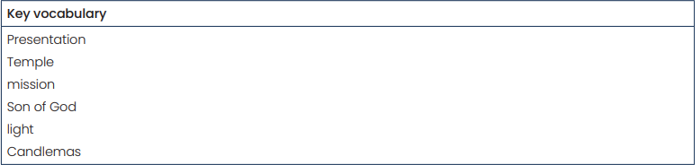

Year 1 – Branch 4 – Desert to Garden

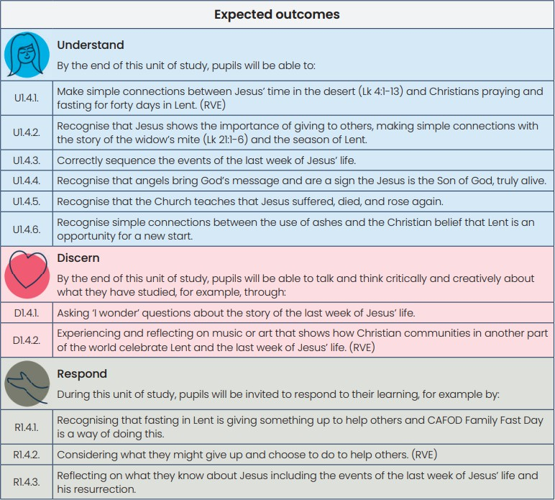
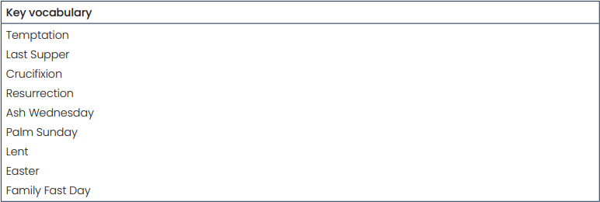

Year 1 – Branch 5 – To the ends of the Earth

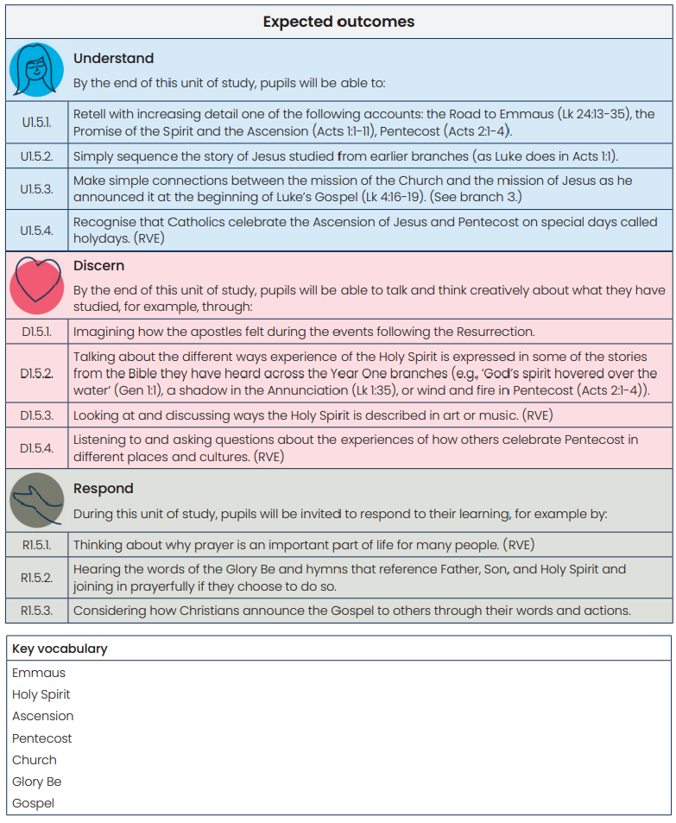

Year 1 – Branch 6 – Dialogue and Encounter

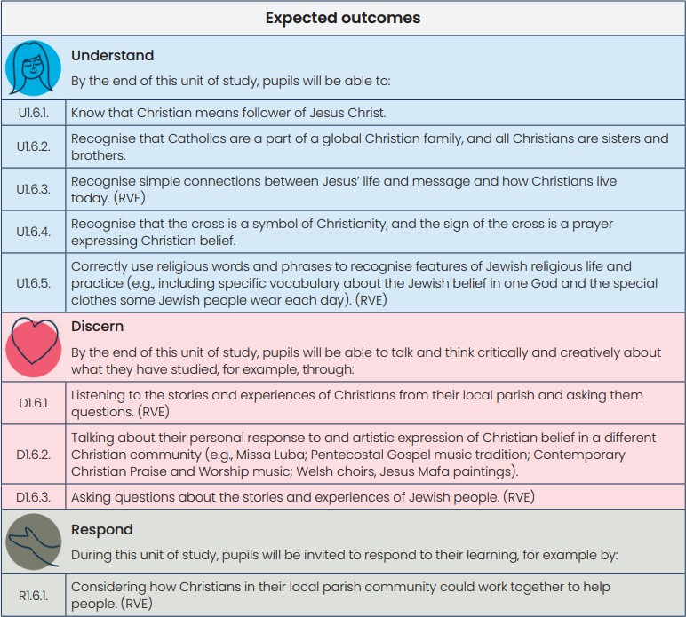
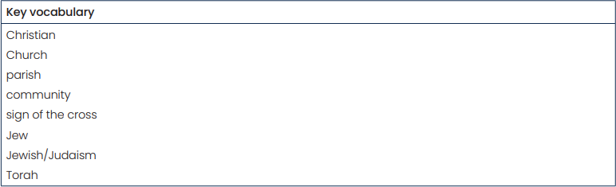

Year 2 – Branch 1 – Creation and Covenant
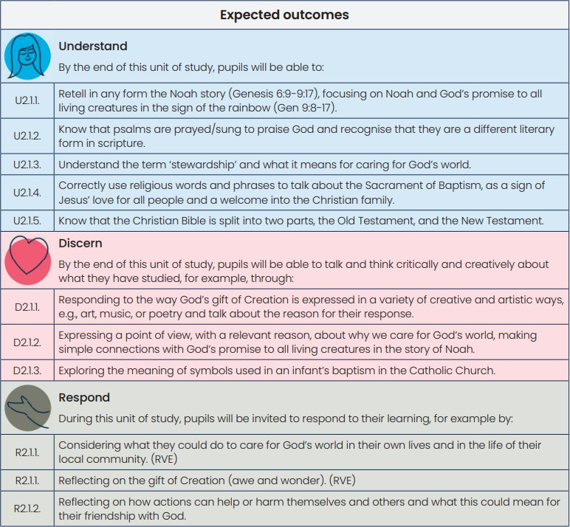
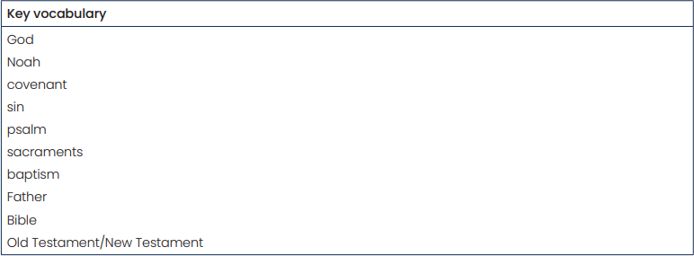

Year 2 – Branch 2 – Prophecy and Promise
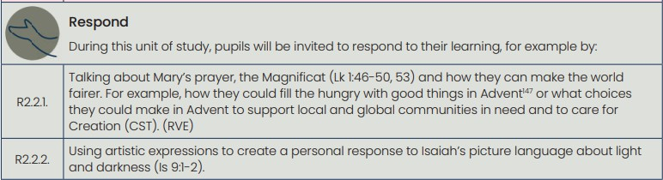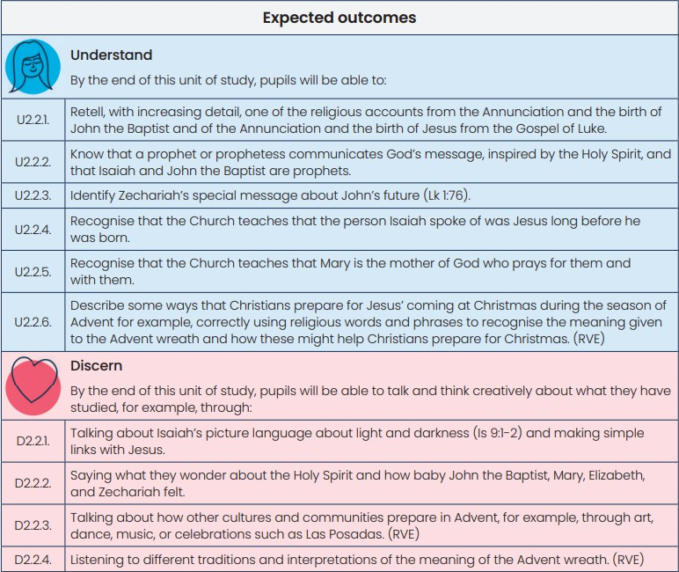
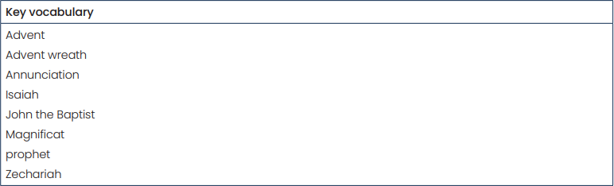

Year 2 – Branch 3 – Galilee to Jerusalem

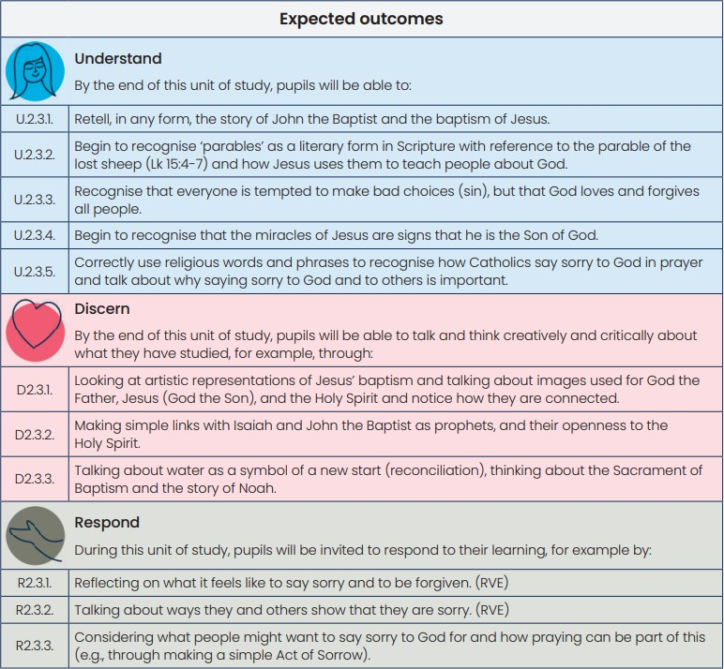
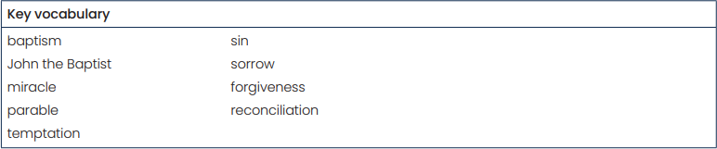

Year 2 – Branch 4 – Desert to Garden

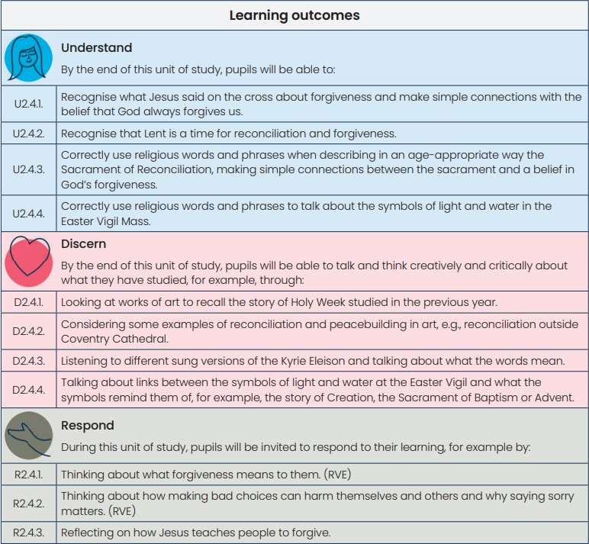
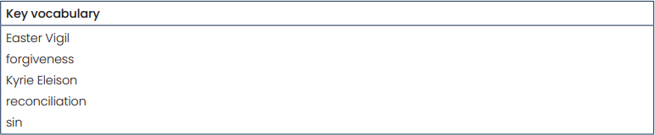

Year 2 – Branch 5 – To the ends of the Earth

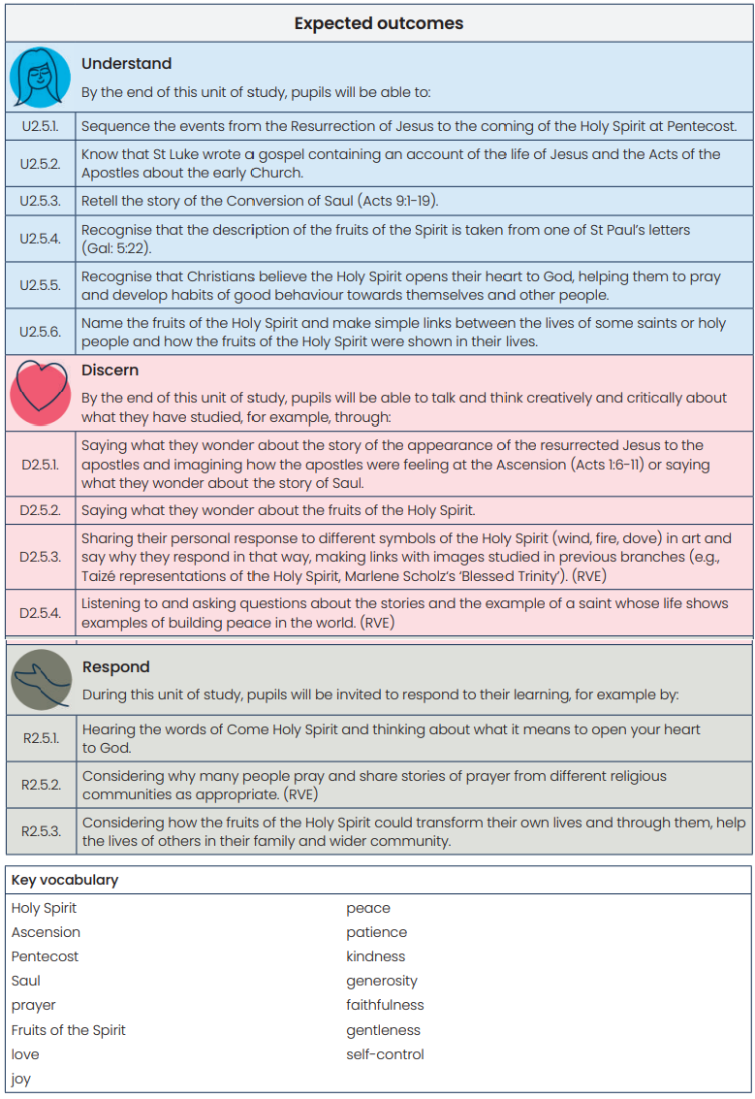

Year 2 – Branch 6 – Dialogue and Encounter
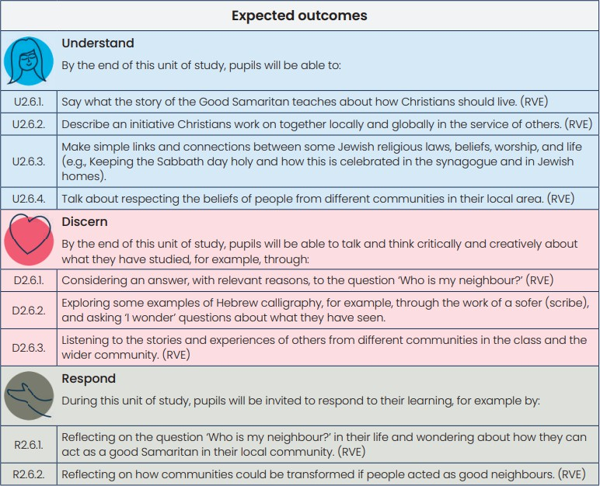
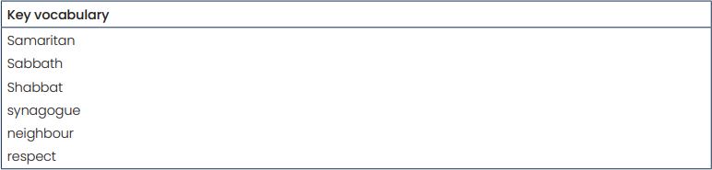

Year 3 – Branch 1 – Creation and Covenant

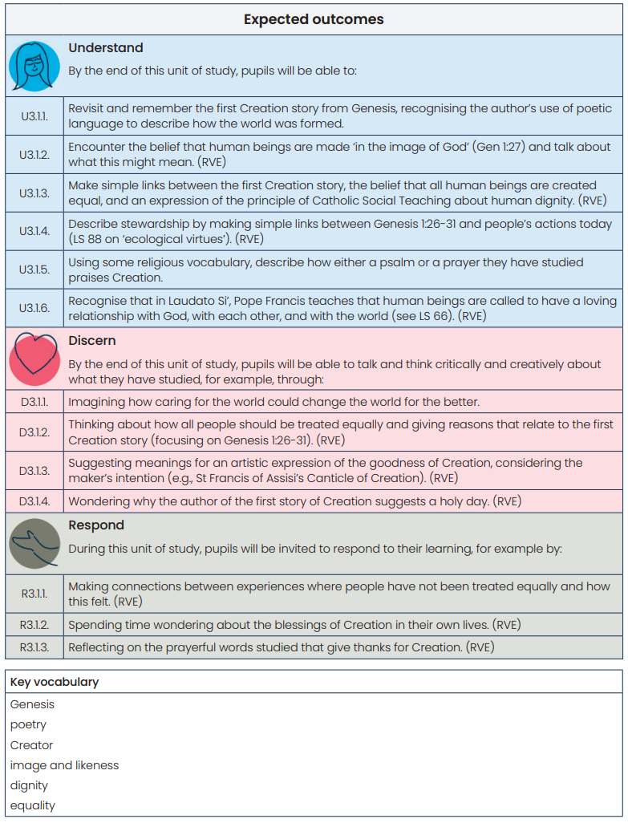

Year 3 – Branch 2 – Prophecy and Promise
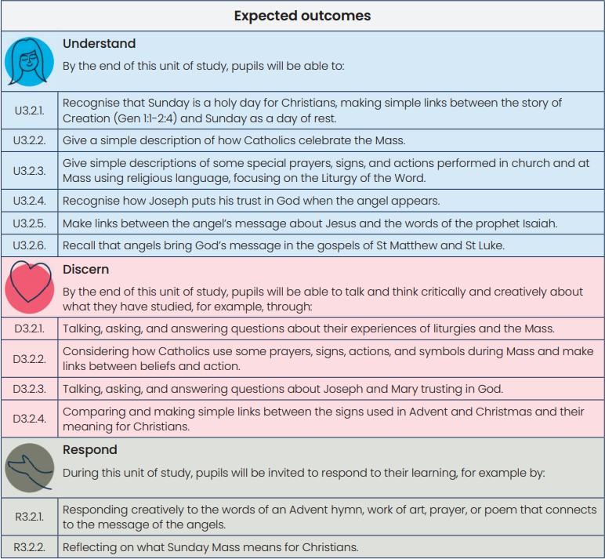
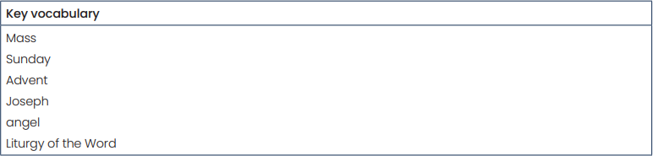

Year 3 – Branch 3 – Galilee to Jerusalem
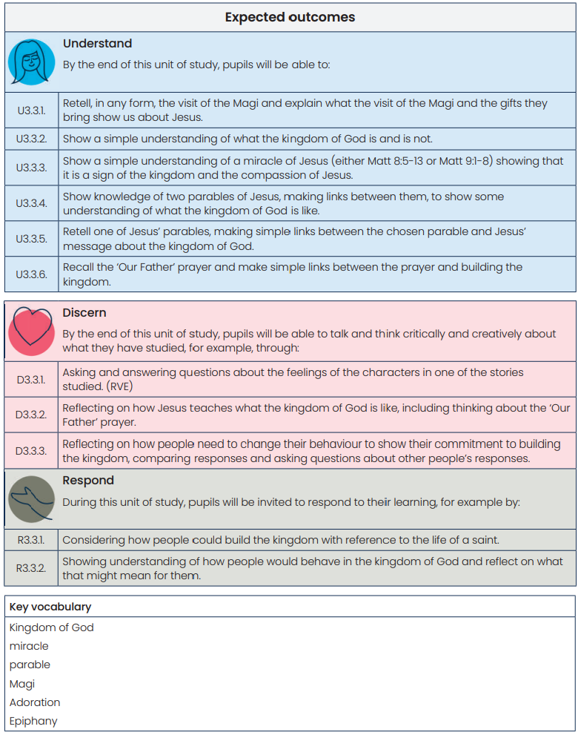

Year 3 – Branch 4 – Desert to Garden

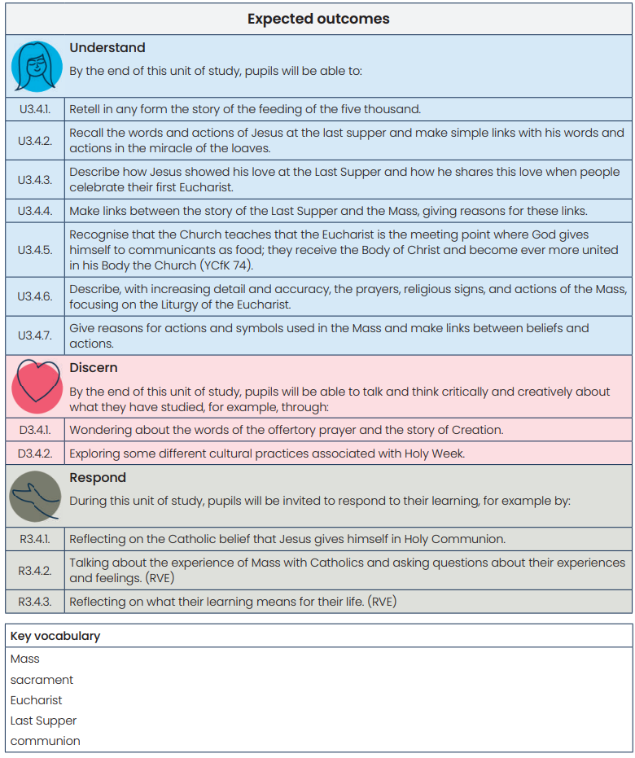

Year 3 – Branch 5 – To the ends of the Earth

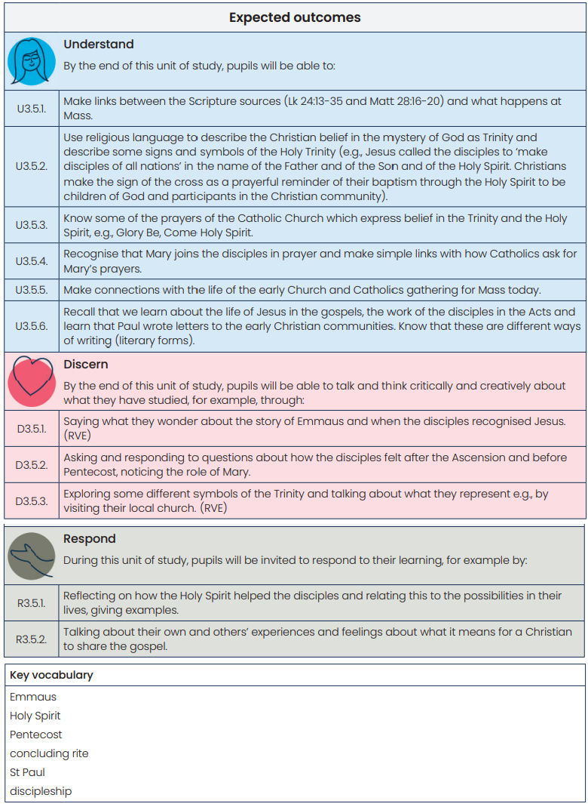

Year 3 – Branch 6 – Dialogue and Encounter

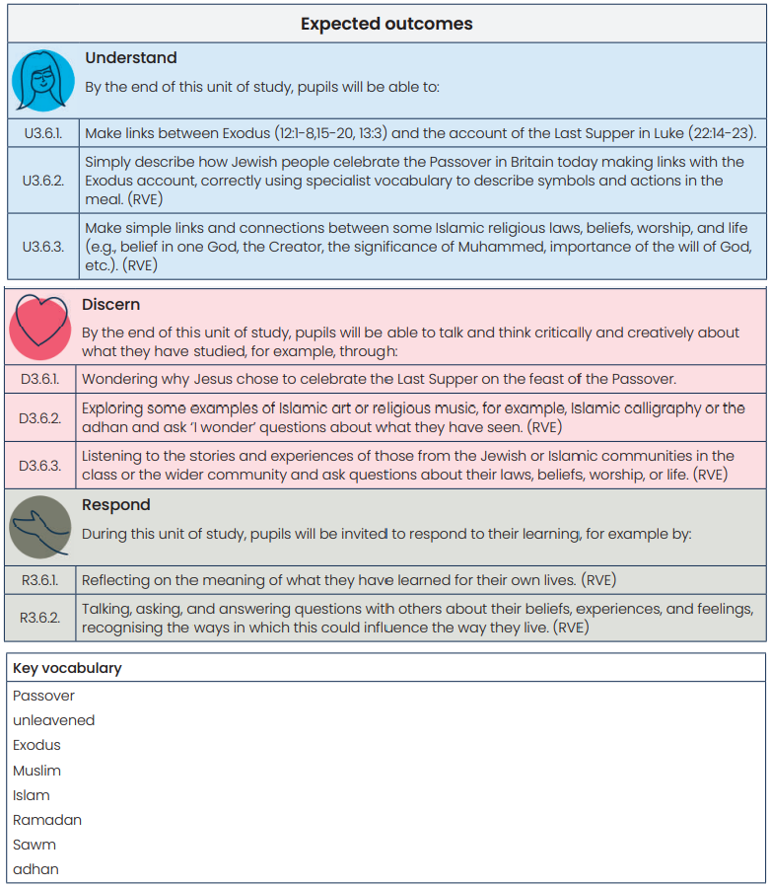

Year 4 – Branch 1 – Creation and Covenant

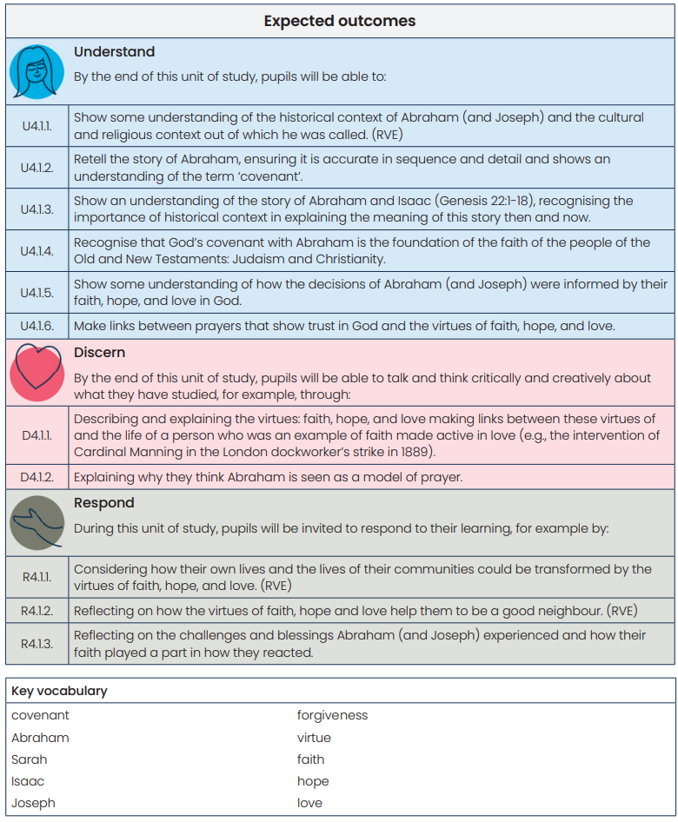

Year 4 – Branch 2 – Prophecy and Promise
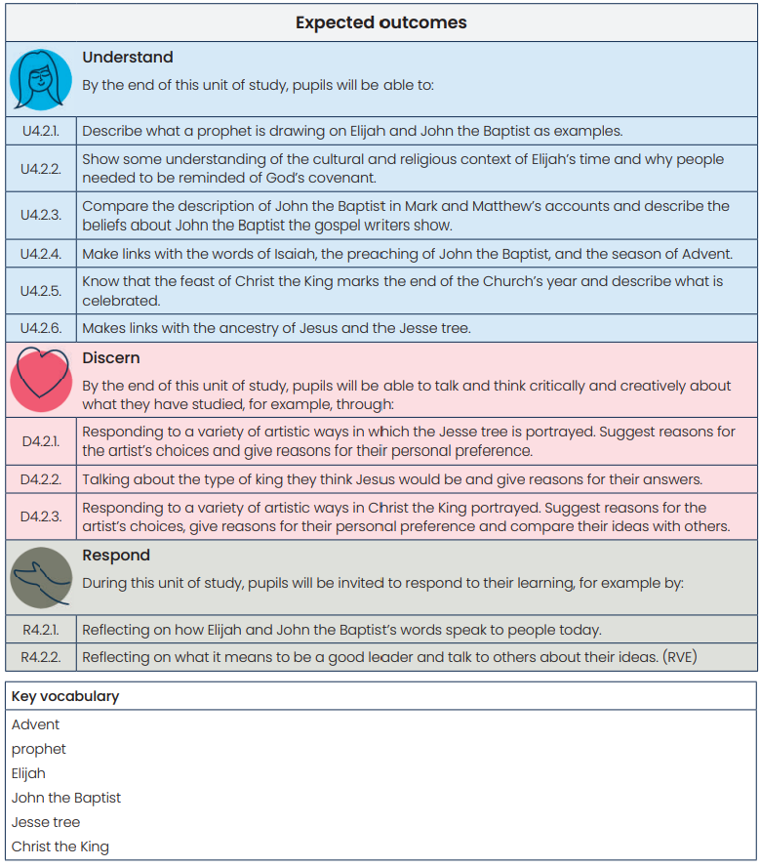

Year 4 – Branch 3 – Galilee to Jerusalem

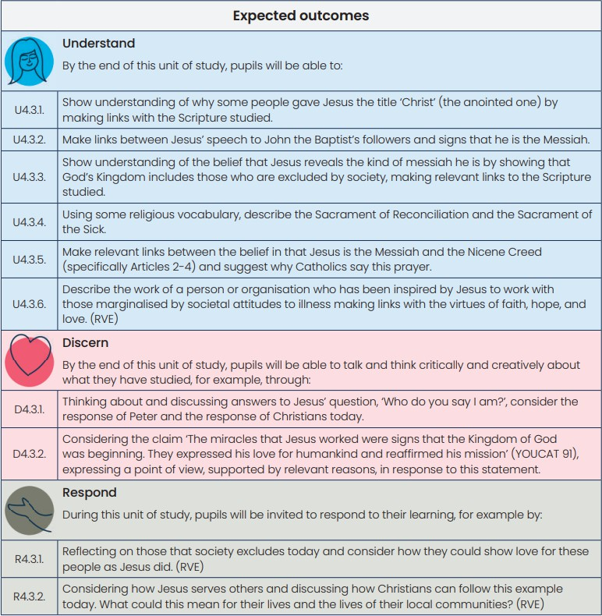
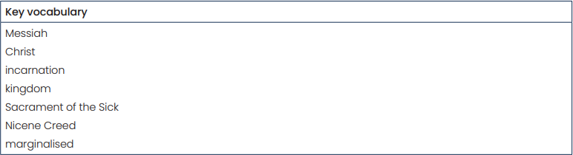

Year 4 – Branch 4 – Desert to Garden

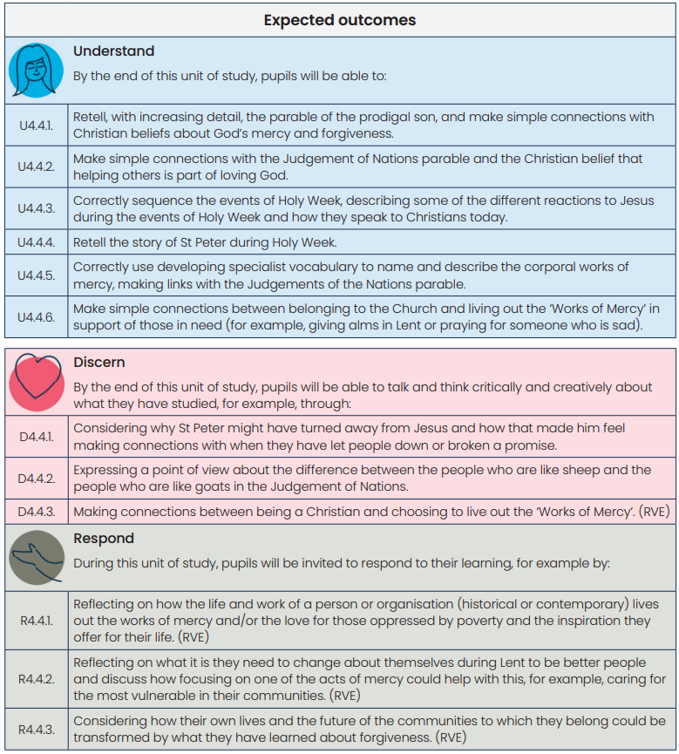
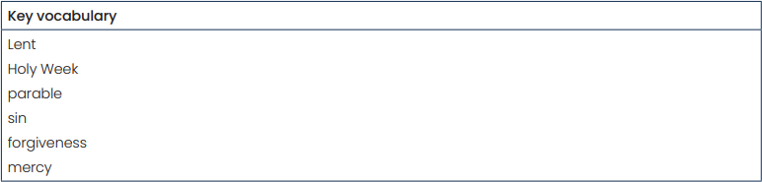

Year 4 – Branch 5 – To the ends of the Earth

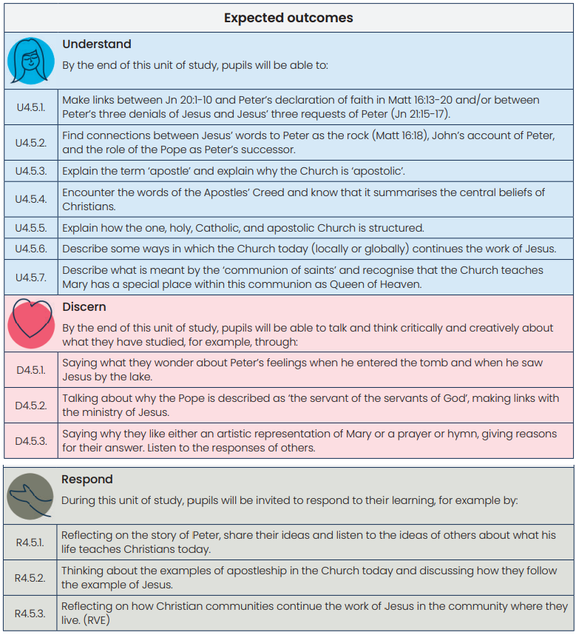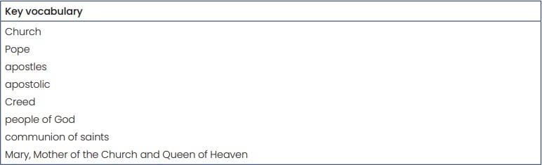

Year 4 – Branch 6 – Dialogue and Encounter

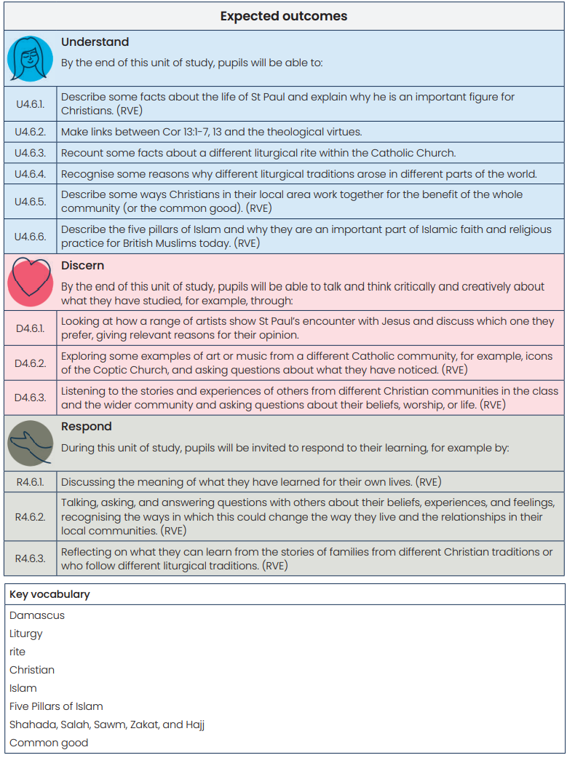
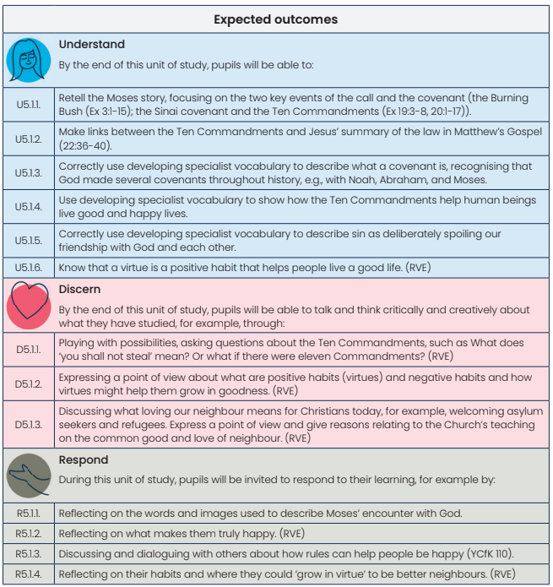
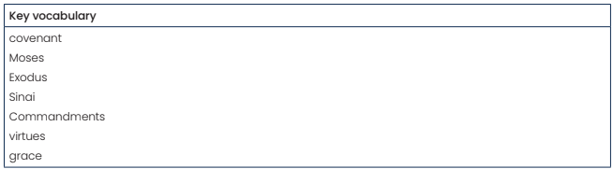
Year 5 – Branch 1 – Creation and Covenant

Year 5 – Branch 2 – Prophecy and Promise
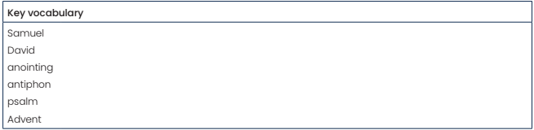
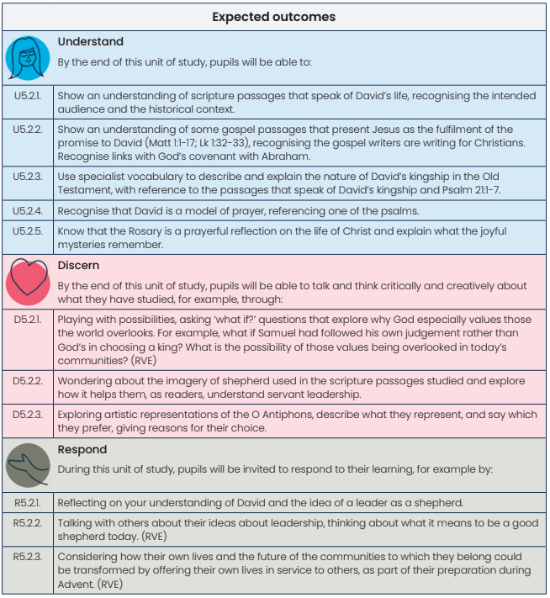

Year 5 – Branch 3 – Galilee to Jerusalem

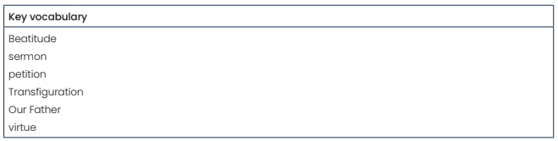
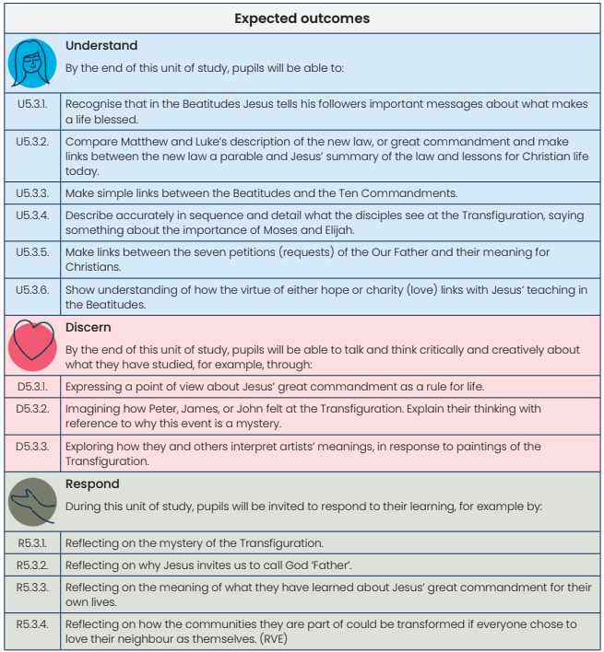

Year 5 – Branch 4 – Desert to Garden

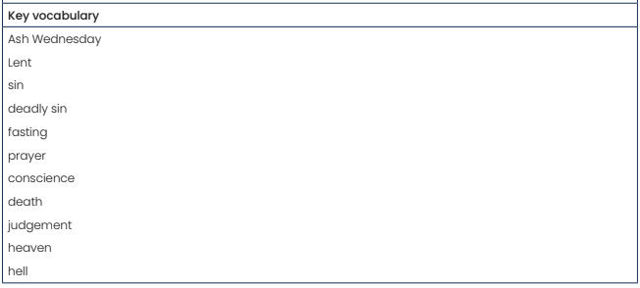
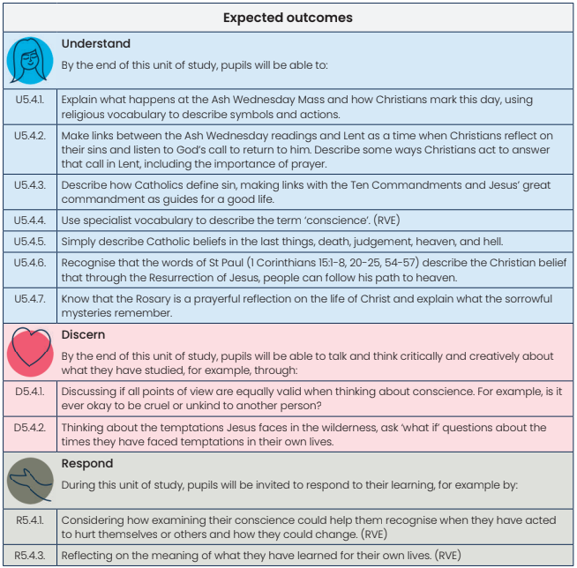
Year 5 – Branch 5 – To the ends of the Earth

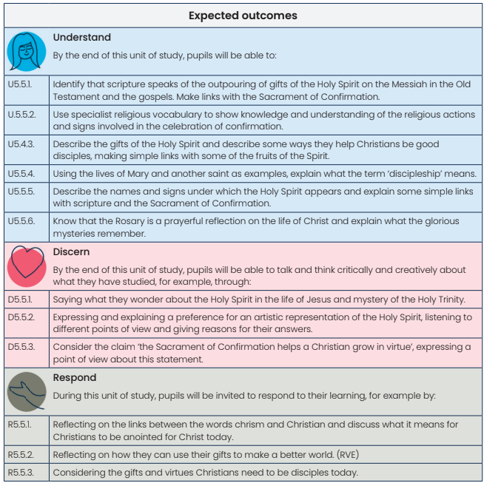
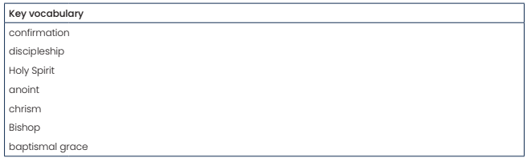

Year 5 – Branch 6 – Dialogue and Encounter
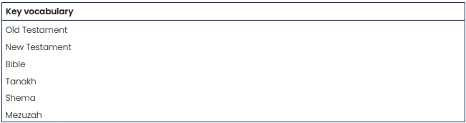
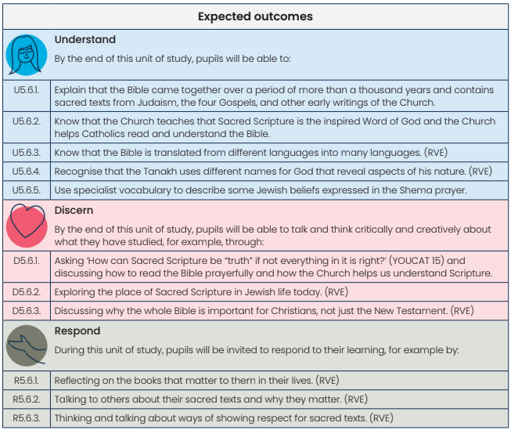

Year 6 – Branch 1 – Creation and Covenant

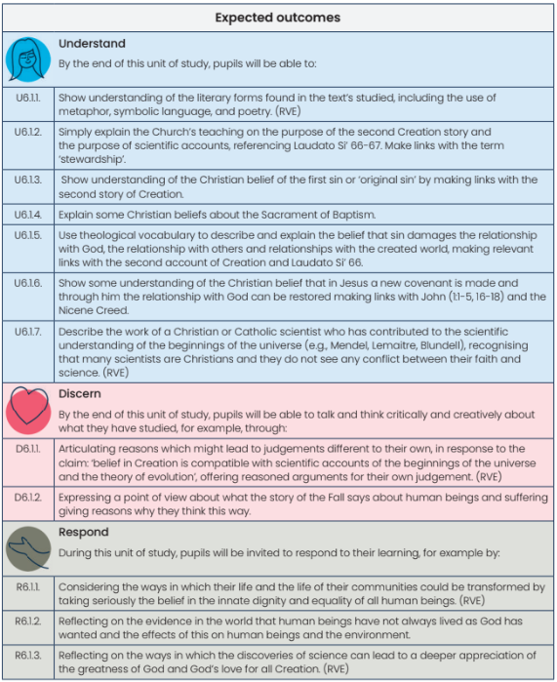
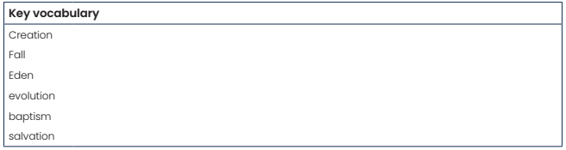

Year 6 – Branch 2 – Prophecy and Promise

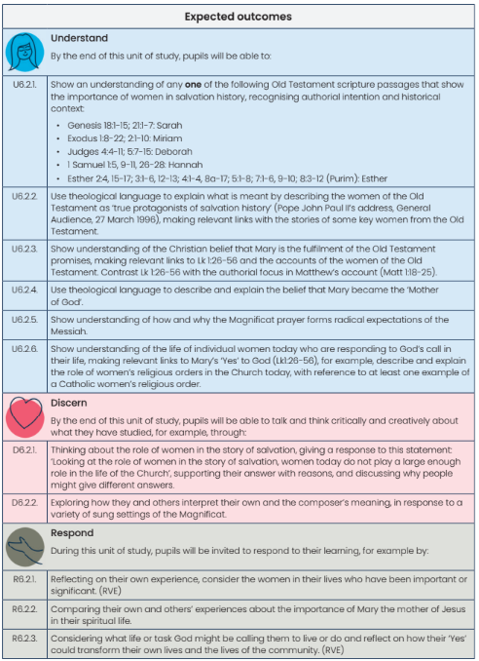
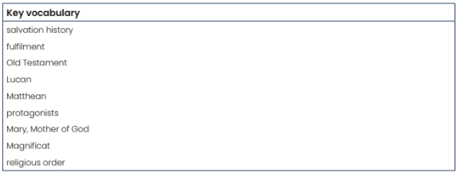
Year 6 – Branch 3 – Galilee to Jerusalem

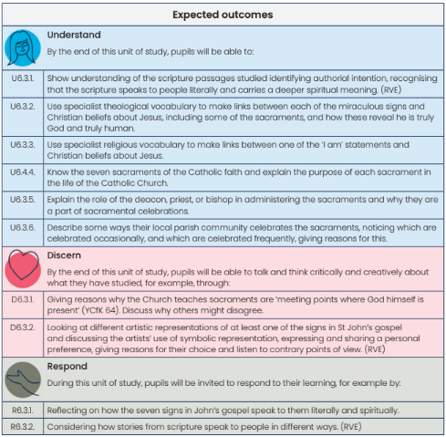

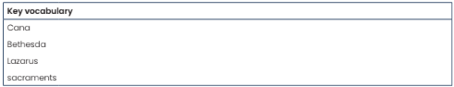

Year 6 – Branch 4 – Desert to Garden

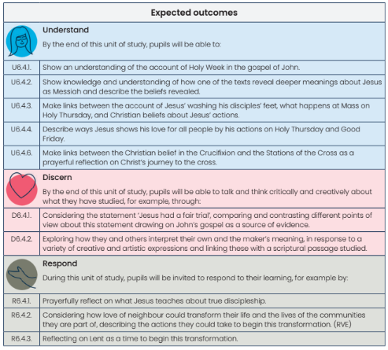
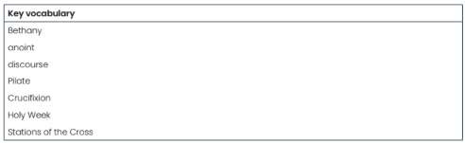

Year 6 – Branch 5 – To the ends of the Earth
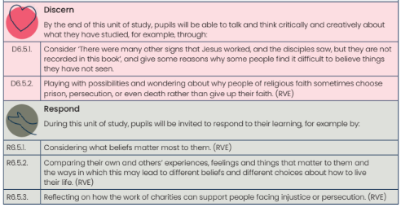
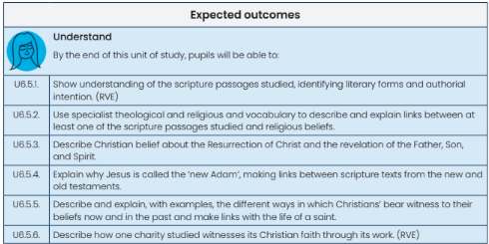
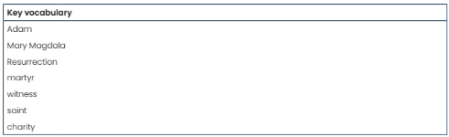

Year 6 – Branch 6 – Dialogue and Encounter
