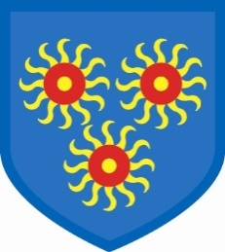
St Edmund’s Catholic Primary School
Diocese of Westminster
www.st-edmunds-school.org
Follow us on twitter @stedmundsschoo1
Parents Newsletter 6th March 2020
World Book Day

We will be celebrating this on Friday, 13th March. Children are encouraged to come to school dressed as their favourite character from a book.

Science Week

This will now be taking place in the Summer Term. More details to follow nearer the time.

Class Assemblies
Friday, 20th March: Reception
Friday, 27th March: Year 3

Dates for the diary

Monday, 16th & Tuesday, 17th March: Parent conferences
Thursday, 19th March: Danceathon
Thursday, 26th –Tuesday, 31st March: book fair visiting
Wednesday, 1st April: Easter Tea Party
Friday, 3rd April: Last day of term. School will finish at 2pm on this day.

Parent conferences
These will be taking place on Monday, 16th and Tuesday, 17th March. You can sign up online for these now. Please bring your child with you.

Lenten Appeal
The children will be taking part in a school Danceathon on Thursday, 19th March. All money raised will go towards supporting our two charities this year. We are raising money for the Catholic Children’s Society and Dogs on the Street, a charity that supports rough sleepers and the homeless community with dogs. We will be sending sponsorship forms home soon.

Easter Tea Party
This will be taking place on Wednesday, 1st April at 3pm in the hall. Please come and enjoy some tea and cake with us! All donations raised will go towards supporting our two charities this year.

Year 3

In Year 3, we have been practising our research and note-taking skills. Our topic this term is William Shakespeare so we have been finding out all about him. We have each become experts about a certain part of his life and we have shared our new knowledge in groups. This is called a ‘jigsaw’. We are also really enjoying reading an adaptation of Shakespeare’s play, The Tempest.

